Presence Kritik
1NC
Presence K---1NC 3

Links
Link: geography 8
Link: military presence 9
Link: war 10
Link: just war theory 11
Link: war/solvency 12
Link: war 13
Link: military presence 14
Link: military bases 15
Link: military presence 16
Link: military reduction 17
Link: troop reduction 18
Link: death at bay 19
Link: war/pure speed 20
Link: presence of war 21
Link: presence 22
Link: “healing the wound” 25
Link: peace 26
Link: improvement 27
Link: presence 28
Link: geopolitics/manipulation of IR 29
Link: presence 30
Link: COIN aff 31
Link: logistics 32
Link: nukes 33
Link: international/domestic dichotomy 34
Link: state centrism/AT: framework 35
Link: afghanistan 36
Link: presence 37
Link - Afghanistan War – Repression Schema K 38

Impacts
Impact: violence 39
Impact: environment 41
Impact: dehumanization 42
Impact: nihilism 43
turns the case 44

Alternative
Alt - Question 45
AT: alternative doesn’t solve 46
AT: Perm 50

Framework
Discourse 52
AT: framework/role of ballot 53
AT: framework/role of ballot 54
AT: framework 55
AT: framework—war on terror/middle east (1/2) 59
AT: framework—war on terror/middle east (2/2) 60
AT: framework 61
AT: framework 62
AT: framework 63
Presence K---1NC
Their removal of troops serves as a mask for their continuation of warfare through speech. They do not end a war; they just continue it by other means. The end result of this cycle of violent action and then speech can only be one thing: total warfare.
Foucault 80. Michel Foucault, professor of histories of systems of thought at the College de France, 1980, Power/Knowledge: Selected Interviews and Other Writings, pg. 90-91
Then again, there is a second reply we might make: if power is properly speaking the way in which relations of forces are deployed and given concrete expression, rather than analysing it in terms of cession, contract or alienation, or functionally in terms of its maintenance of the relations of production, should we not analyse it primarily in terms of struggle, conflict and war? One would then confront the original hypothesis, according to which power is essentially repression, with a second hypothesis to the effect that power is war, a war continued by other means. This reversal of Clausewitz's assertion that war is politics continued by other means has a triple significance: in the first place, it implies that the relations of power that function in a society such as ours essentially rest upon a definite relation of forces that is established at a determinate, historically specifiable moment, in war and by war. Furthermore, if it is true that political power puts an end to war, that it installs, or tries to install, the reign of peace in civil society, this by no means implies that it suspends the effects of war or neutralises the disequilibrium revealed in the final battle. The role of political power, on this hypothesis, is perpetually to re- inscribe this relation through a form of unspoken warfare; to re-inscribe it in social institutions, in economic inequalities, in language, in the bodies themselves of each and everyone of us. So this would be the first meaning to assign to the inversion of Clausewitz's aphorism that war is politics continued by other means. It consists in seeing politics as sanctioning and upholding the disequilibrium of forces that was displayed in war. But there is also something else that the inversion signifies, namely, that none of the political struggles, the conflicts waged over power, with power, for power, the alterations in the relations of forces, the favour ing of certain tendencies, the reinforcements etc., etc., that come about within this 'civil peace5 -that none of these phenomena in a political system should be interpreted except as the continuation of war. They should, that is to say, be understood as episodes, factions and displacements in that same war. Even when one writes the history of peace and its institutions, it is always the history of this war that one is writing. The third, and final, meaning to be assigned to the inversion of Clausewitz's aphorism, is that the end result can only be the outcome of war, that is, of a contest of strength, to be decided in the last analyses by recourse to arms. The political battle would cease with this final battle. Only a final battle of that kind would put an end, once and for all, to the exercise of power as continual war.

Presence K---1NC
Our presence has made war a non-normative occurrence making the possibility of destruction always present, and thusly always governing the social and political in some form.
Noorani 5 (YASEEN, University of Arizona, Tucson) The Rhetoric of Security, Project Muse, The New Centennial Review, Volume 5, Number 1, Spring 2005, http://muse.jhu.edu/login?ur i=/journals/new_centennial_review/v005/5.1noorani.pdf, p. 14)CS
In The Concept of the Political, ﬁrst published in 1932, Schmitt develops the Hobbesian notion of the state of war always in effect among nations. On this basis, he distinguishes the “political” from other areas of human existence by its concern with the preservation of one’s existence as such. The agency that exists for the purpose of preserving existence is the state, and its means of fulﬁlling this purpose is its capacity to distinguish friends from enemies. Schmitt’s point of departure is the possibility that some alien group of people may at some time try to destroy the group of people to which I belong. In this case, normative considerations go out the window, and my group of people simply does whatever it can to preserve itself from extinction. According to Schmitt, self-preservation is a primordial fact out- side of moral normativity. War, the readiness of combatants to die, the physical killing of human beings who belong on the side of the enemy—all this has no normative meaning, but an existential meaning only, particularly in a real combat sit- uation with a real enemy. There exists no rational purpose, no norm no mat- ter how true, no program no matter how exemplary, no social ideal no matter how beautiful, no legitimacy nor legality which could justify men in killing each other for this reason. If such physical destruction of human life is not motivated by an existential threat to one’s own way of life, then it can- not be justiﬁed. (Schmitt 1996, 48–49) The idea here is that no end or objective having to do with the way we think things ought to begin to justify dying and killing. We are only driven to these in cases of pure necessity, when we merely need to survive. For Schmitt, this non-normative condition of the state of war is the essence of the political, because the possibility of destruction at the hands of an enemy is always present and must therefore govern the nature of social organization and political authority. The problem with liberalism, in Schmitt’s view, is that it does not even take this foundational eventuality of politics into account in formulating its principles. Since liberal doctrine holds that individuals and nations may live peacefully by respecting each other’s autonomy, liberalism provides no incentive for organizing society so as to confront potential threats to it. Liberal principles endanger the nation by placing all value in individual liberty and rights and none in the require- ments of national security. Indeed, liberal individualism has no means of demanding self-sacriﬁce from citizens for the sake of the nation.

Presence K---1NC
The removal of physical presence just allows a new mechanism of total, technological control to cement its control over society. We no longer need to be everywhere in the world because we are omnipresent in the minds of everyone in the world. As this method trickles down to our individual interactiosn with the world, we begin to crave death as life becomes meaningless.
Virilio 2k. Paul Virilio, Director of the Ecole Speciale d’Architecutre, Paris, A Landscape of Events, pg. 61-62
No longer to travel, except on the spot. No longer to stretch ourselves, to spread ourselves thin in the passing distraction of a physical journey, but just to relax here and now, in the inertia of immobility regained. Social quietism leads our societies to wrap themselves in the shroud of interior comfort, the bliss of a reverse vitality in which lack of action becomes the height of passion. A society of hardened lounge lizards, where everyone hopes not to die or suffers, as Western masochism has been said to want, but to be dead.
The whole panopoly of the latest technologies invites us suddenly to be stuck at home under the house arrest of telematics and the electronic workplace, which turn erstwhile televiewers into telereactors in an instantaneous interactivity that exiles us from real space, from contact with our fellow man.
A remarkable convergence between hidden desire for sensory privatization and this technological assistance, this assisted conception of existence: the pleasure of the rendezvous at a distance, of a get-together without getting together, pleasure without risk of contamination offered by the anonymous telecommunications of the erotic Minitel or the Walkman; abandoning our fellow man in favor of unknown and distant beings who remain aloof, ghosts of no importance who won’t mess up our plans.

Presence K---1NC
We have all been taken into the war-machine, the only question is whether we accept this as fact or overcome it. The aff, most likely unknowingly, reinforces the machinery with their assurance that all that is needed is a new plan, a different logistics. Reducing our agency to the calculations of military strategy makes us what Virilio calls “unknown soldiers of the order of speeds” – in affect militant consumers without a cause.
Mansfield 8 (Nick, Profesor of Cultural Studies at Macquarie University in Sydney, Australia, Theorizing War: From Hobbes to Bandiou p. 133) CS
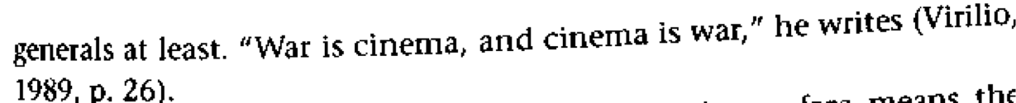
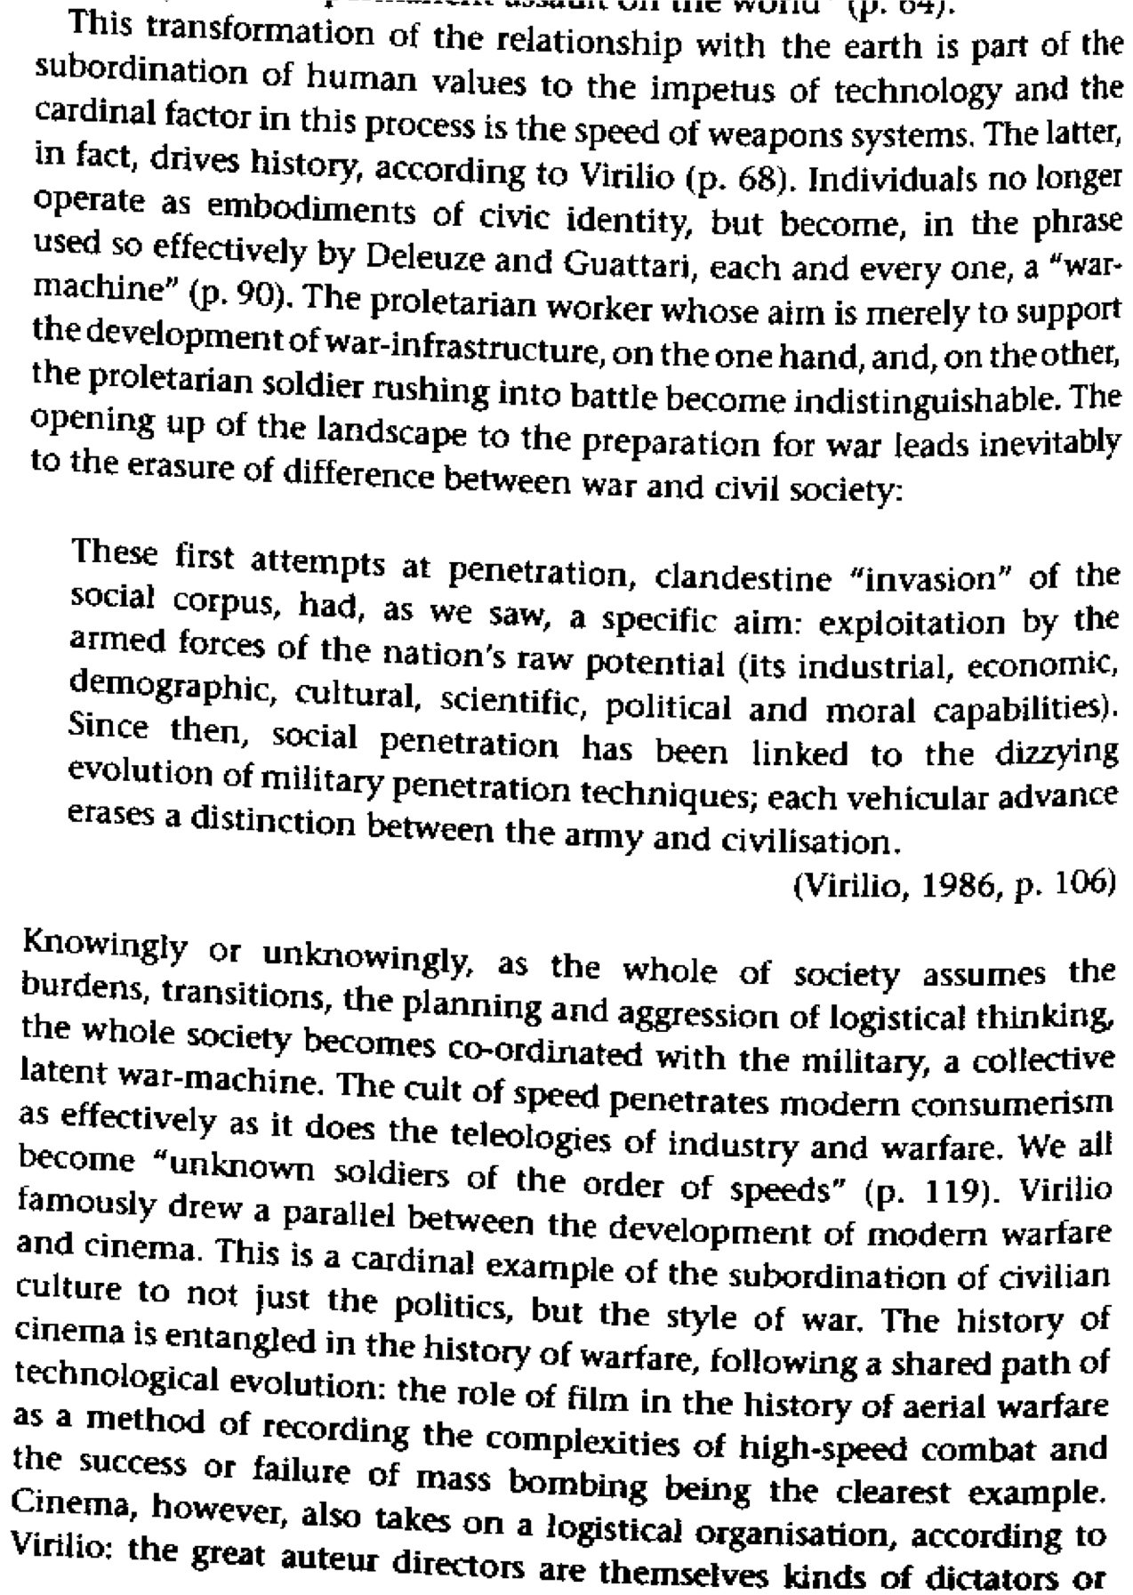

Presence K---1NC
Our alternative is to reject the affirmative for their framing of presence. We must attend to the way that military practices are woven into the very fabric of life in the twenty-first century before evaluating their crises-based politics and analyses. The perm doesn’t solve because the 1ac’s conflated, big impacts shield structural militarism and crowd out our alternative.
Cuomo 96. Chris J. Cuomo, professor of philosophy at the University of Georgia, “War Is Not Just an Event: Reflections on the Significance of Everyday Violence,” Hypatia, Vol. 11, No. 4, Women and Violence (Autumn, 1996), pg. 30-45, jstor
Theory that does not investigate or even notice the omnipresence of militarism cannot represent or address the depth and specificity of the everyday effects of militarism on women, on people living in occupied territories, on members of military institutions, and on the environment. These effects are relevant to feminists in a number of ways because military practices and institutions help construct gendered and national identity, and because they justify the destruction of natural nonhuman entities and communities during peacetime. Lack of attention to these aspects of the business of making or preventing military violence in an extremely technologized world results in theory that cannot accommodate the connections among the constant presence of militarism, declared wars, and other closely related social phenomena, such as nationalistic glorifications of motherhood, media violence, and current ideological gravitations to military solutions for social problems.
Ethical approaches that do not attend to the ways in which warfare and military practices are woven into the very fabric of life in twenty-first century technological states lead to crisis-based politics and analyses. For any feminism that aims to resist oppression and create alternative social and political options, crisis-based ethics and politics are problematic because they distract attention from the need for sustained resistance to the enmeshed, omnipresent systems of domination and oppression that so often function as givens in most people's lives. Neglecting the omnipresence of militarism allows the false belief that the absence of declared armed conflicts is peace, the polar opposite of war.
It is particularly easy for those whose lives are shaped by the safety of privilege, and who do not regularly encounter the realities of militarism, to maintain this false belief. The belief that militarism is an ethical, political concern only regarding armed conflict, creates forms of resistance to militarism that are merely exercises in crisis control. Antiwar resistance is then mobilized when the "real" violence finally occurs, or when the stability of privilege is directly threatened, and at that point it is difficult not to respond in ways that make resisters drop all other political priorities. Crisis-driven attention to declarations of war might actually keep resisters complacent about and complicitous in the general presence of global militarism. Seeing war as necessarily embedded in constant military presence draws attention to the fact that horrific, state-sponsored violence is happening nearly all over, all of the time, and that it is perpetrated by military institutions and other militaristic agents of the state.
Moving away from crisis-driven politics and ontologies concerning war and military violence also enables consideration of relationships among seemingly disparate phenomena, and therefore can shape more nuanced theoretical and practical forms of resistance. For example, investigating the ways in which war is part of a presence allows consideration of the relationships among the events of war and the following: how militarism is a foundational trope in the social and political imagination; how the pervasive presence and symbolism of soldiers/warriors/patriots shape meanings of gender; the ways in which threats of state-sponsored violence area sometimes invisible/sometimes bold agent of racism, nationalism, and corporate interests; the fact that vast numbers of communities, cities, and nations are currently in the midst of excruciatingly violent circumstances. It also provides a lens for considering the relationships among the various kinds of violence that get labeled "war." Given current American obsessions with nationalism, guns, and militias, and growing hunger for the death penalty, prisons, and a more powerful police state, one cannot underestimate the need for philosophical and political attention to connections among phenomena like the "war on drugs," the "war on crime," and other state-funded militaristic campaigns.
I propose that the constancy of militarism and its effects on social reality be reintroduced as a crucial locus of contemporary feminist attentions, and that feminists emphasize how wars are eruptions and manifestations of omnipresent militarism that is a product and tool of multiply oppressive, corporate, technocraticstates.2 Feminists should be particularly interested in making this shift because it better allows consideration of the effects of war and militarism on women, subjugated peoples, and environments. While giving attention to the constancy of militarism in contemporary life we need not neglect the importance of addressing the specific qualities of direct, large-scale, declared military conflicts. But the dramatic nature of declared, large-scale conflicts should not obfuscate the ways in which military violence pervades most societies in increasingly technologically sophisticated ways and the significance of military institutions and everyday practices in shaping reality. Philosophical discussions that focus only on the ethics of declaring and fighting wars miss these connections, and also miss the ways in which even declared military conflicts are often experienced as omnipresent horrors. These approaches also leave unquestioned tendencies to suspend or distort moral judgement in the face of what appears to be the inevitability of war and militarism.
Link: geography
Pure speed has made geographic distinctions irrelevant. The new mechanism of imperialism makes physical presence irrelevant, while actually giving us more strategic power of populations.
Mansfield 8 (Nick, Profesor of Cultural Studies at Macquarie University in Sydney, Australia, Theorizing War: From Hobbes to Bandiou p. 133) CS

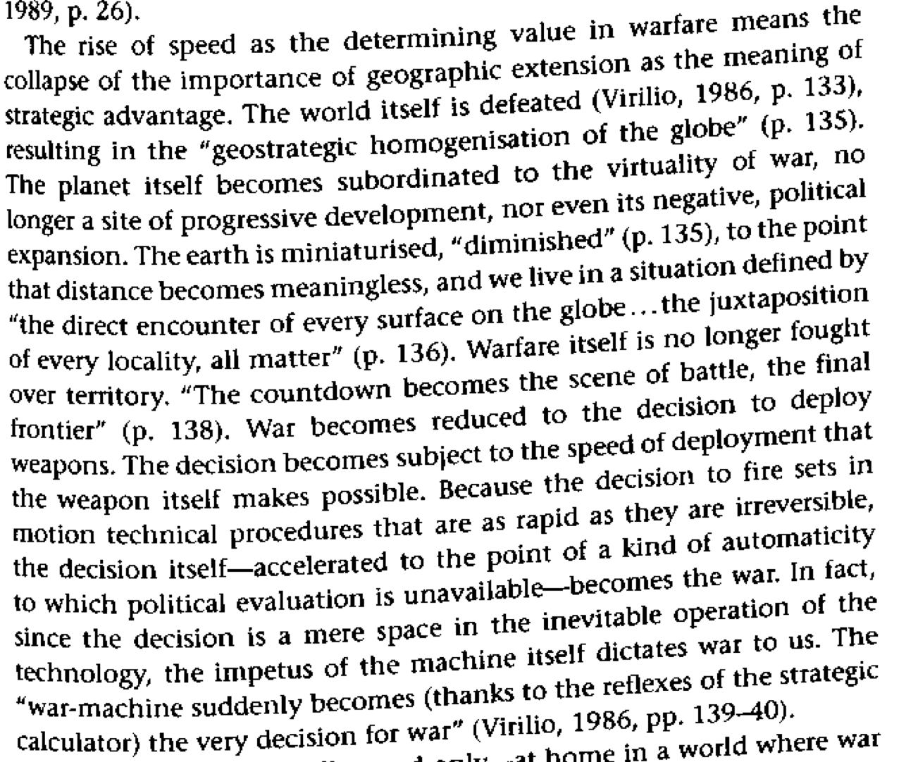

Link: military presence
Focusing only military forces obscures everyday militarism that pervades every facet of our lives. By locating conflict as somewhere “out there,” such as in Afghanistan, and trying to strategically end it, we are able to vacate responsibility for our complicity in a constant warfare against difference.
Cuomo 96. Chris J. Cuomo, professor of philosophy at the University of Georgia, “War Is Not Just an Event: Reflections on the Significance of Everyday Violence,” Hypatia, Vol. 11, No. 4, Women and Violence (Autumn, 1996), pg. 30-45, jstor
Philosophical attention to war has typically appeared in the form of justifications for entering into war, and over appropriate activities within war. The spatial metaphors used to refer to war as a separate, bounded sphere indicate assumptions that war is a realm of human activity vastly removed from normal life, or a sort of happening that is appropriately conceived apart from everyday events in times. Not most discussions of the and peaceful surprisingly, political ethical dimensions of war discuss war solely as an event-an occurrence, or collection of occurrences, having clear beginnings and endings that are typically marked by formal, institutional declarations. As happenings, wars and military activities can be seen as motivated by identifiable, if complex, intentions, and directly enacted by individual and collective decision-makers and agents of states. But many of the questions about war that are of interest to feminists-including how large-scale, state-sponsored violence affects women and members of other oppressed groups; how military violence shapes gendered, raced, and nationalistic political realities and moral imaginations; what such violence consists of and why it persists; how it is related to other oppressive and violent institutions and hegemonies-cannot be adequately pursued by focusing on events. These issues are not merely a matter of good or bad intentions and identifiable decisions.

Link: war
Conceptualizing war as a single event that can be “ended” with the flip of a switch (or an aff ballot) makes it so that we whitewash and glaze over racial and gendered understandings of systemic violence.
Cuomo 96. Chris J. Cuomo, professor of philosophy at the University of Georgia, “War Is Not Just an Event: Reflections on the Significance of Everyday Violence,” Hypatia, Vol. 11, No. 4, Women and Violence (Autumn, 1996), pg. 30-45, jstor
In "Gender and 'Postmodern' War," Robin Schott introduces some of the ways in which war is currently best seen not as an event but as a presence (Schott 1995). Schott argues that postmodem understandings of persons, states, and politics, as well as the high-tech nature of much contemporary warfare and the preponderance of civil and nationalist wars, render an event-based conception of war inadequate, especially insofar as gender is taken into account. In this essay, I will expand upon her argument by showing that accounts of war that only focus on events are impoverished in a number of ways, and therefore feminist consideration of the political, ethical, and ontological dimensions of war and the possibilities for resistance demand a much more complicated approach. I take Schott's characterization of war as presence as a point of departure, though I am not committed to the idea that the constancy of militarism, the fact of its omnipresence in human experience, and the paucity of an event-based account of war are exclusive to contemporary postmodern or postcolonialcircumstances.1

Link: just war theory
Just war theory cannot explain the systemic militarism that takes place against gendered and racial underclasses.
Cuomo 96. Chris J. Cuomo, professor of philosophy at the University of Georgia, “War Is Not Just an Event: Reflections on the Significance of Everyday Violence,” Hypatia, Vol. 11, No. 4, Women and Violence (Autumn, 1996), pg. 30-45, jstor
Just-war theory is a prominent example of a philosophical approach that rests on the assumption that wars are isolated from everyday life and ethics. Such theory, as developed by St. Augustine, Thomas Aquinas, and Hugo Grotius, and as articulated in contemporary dialogues by many philosophers, including Michael Walzer (1977), Thomas Nagel (1974), and Sheldon Cohen (1989), take the primary question concerning the ethics of warfare to be about when to enter into military conflicts against other states. They therefore take as a given the notion that war is an isolated, definable event with clear boundaries. These boundaries are significant because they distinguish the circumstances in which standard moral rules and constraints, such as rules against murder and unprovoked violence, no longer apply. Just-war theory assumes that war is a separate sphere of human activity having its own ethical constraints and criteria and in doing so it begs the question of whether or not war is a special kind of event, or part of a pervasive presence in nearly all contemporary life.
Because the application of just-war principles is a matter of proper decision- making on the part of agents of the state, befure wars occur, and before military strikes are made, they assume that military initiatives are distinct events. In fact, declarations of war are generally overdetermined escalations of preexist- ing conditions. Just-war criteria cannot help evaluate military and related institutions, including their peacetime practices and how these relate to wartime activities, so they cannot address the ways in which armed conflicts between and among states emerge from omnipresent, often violent, state militarism. The remarkable resemblances in some sectors between states of peace and states of war remain completely untouched by theories that are only able to discuss the ethics of starting and ending direct military conflicts between and among states.

Link: war/solvency
The decision to end an ongoing war just cloaks an ongoing war against the underclasses of our own country because we think we are ending a war and beginning peace—we’re not.
Cuomo 96. Chris J. Cuomo, professor of philosophy at the University of Georgia, “War Is Not Just an Event: Reflections on the Significance of Everyday Violence,” Hypatia, Vol. 11, No. 4, Women and Violence (Autumn, 1996), pg. 30-45, jstor
Applications of just-war criteria actually help create the illusion that the “problem of war” is being addressed when the only considerations are the ethics of declaring wars and of military violence within the boundaries of declarations of war and peace. Though just-war considerations might theoretically help decision-makers avoid specific gross eruptions of military violence, the aspects of war which require the underlying presence of militarism and the direct effects of the omnipresence of militarism remain untouched. There may be important decisions to be made about when and how to fight war, but these must be considered in terms of the many other aspects of contemporary war and militarism that are significant to nonmilitary personnel, including women and nonhumans.
Link: war
Their motivation to escape a specific war disregards the extent to which war is perpetuated by the underlying militarism in society.
Cuomo 96. Chris J. Cuomo, professor of philosophy at the University of Georgia, “War Is Not Just an Event: Reflections on the Significance of Everyday Violence,” Hypatia, Vol. 11, No. 4, Women and Violence (Autumn, 1996), pg. 30-45, jstor
When Peach discusses “alternatives to war,” she is clearly referring to alternatives to entering into war, or to participating in “the escalation of conflicts.” The avoidance of eruptions of military violence is certainly impor- tant, and Peach is correct that feminist insights about conflict resolution could present significant recommendations in this regard. However, feminist moral imagination cannot end there. In thinking of alternatives to war, we need to continue to imagine alternatives to militaristic economies, symbolic systems, values, and political institutions. The task of constructing such alternatives is far more daunting and comprehensive than creating alternatives to a specific event or kind of event.
Pacifist writers as diverse as Gandhi, Martin Luther King, Jr., and Barbara Deming have emphasized the fact that pacifism entails a critique of pervasive, systematichuman violence. Despite its reductionist tendencies, there is much to learn from the ways in which pacifistsconceive of warasa presence,aswell as the pacifist refusal to let go of the ideal of peace. Characterizing pacifism as motivated by the desire to avoid specific events disregards the extent to which pacifism aims to criticize the preconditions underlying events of war.
Link: military presence
By focusing on reducing military presence, they mask the presence of militarism in our everyday life and ignore the reasons why we went to war in the first place.
Cuomo 96. Chris J. Cuomo, professor of philosophy at the University of Georgia, “War Is Not Just an Event: Reflections on the Significance of Everyday Violence,” Hypatia, Vol. 11, No. 4, Women and Violence (Autumn, 1996), pg. 30-45, jstor
But the abstraction of the particularities of war depends on an abstraction of war itself. The distance of such abstraction is created in part by willingness to think of war without considering the presence of war in “peaceful” times. Wars becomes conceptual entities-bjects for consideration-rather than diverse, historically loaded exemplifications of the contexts in which they occur. In order to notice the particular and individual realities of war, attention must be given to the particular, individual, and contextualized causes and effects of pervasive militarism, as well as the patterns and connections among them.
Link: military bases
Simply removing military bases glosses over the way that those bases have shaped many women’s lives—through activities like rape, molestation, and prostitution, these bases have shaped the way that women perceive the world. This form of militarism must be confronted before deciding to remove troops—they obscure this question.
Cuomo 96. Chris J. Cuomo, professor of philosophy at the University of Georgia, “War Is Not Just an Event: Reflections on the Significance of Everyday Violence,” Hypatia, Vol. 11, No. 4, Women and Violence (Autumn, 1996), pg. 30-45, jstor
To give one very clear example of the ways in which just-war evaluations of wars as events fail to address feminist questions about militarism, consider the widespread influence of foreign military bases on gendered national identities and interactions. In Banam, Beaches and Bases: Making Feminist Sense of International Politics (1990), Cynthia Enloe illustrates how, while decision- making and economic power are held primarily by men, international relations and politics are inevitably played out on women’s bodies in myriad ways, propagating racist, nationalist, and colonialist conceptions of femininity. One chapter, “Base Women,’’ is devoted to a discussion of the ways in which local and global sexual politics shape and are shaped through the constant presence of thousands of military bases worldwide-in the symbol of the soldier, the introduction of foreign conceptions of masculinity and femininity, the repro- duction of family structures on military bases, and through systems of prostitu- tion that universally coexist alongside military bases.
Enloe writes, “military politics, which occupy such a large part of intema- tional politics today, require military bases. Bases are artificial societies created out of unequal relations between men and women of different races and classes” and, one might add, different nations (Enloe 1990, 2). T h e constant, global presence of these bases is an example of the mundane givenness and subtle omnipresence of military violence.
Link: military presence
Their understanding of military power as definite and being the “root cause” of their advantage claims ignores the way in which structural militarism, an ideology that infilitrates all aspects of American society, goes hand in hand with concrete military presence.
Cuomo 96. Chris J. Cuomo, professor of philosophy at the University of Georgia, “War Is Not Just an Event: Reflections on the Significance of Everyday Violence,” Hypatia, Vol. 11, No. 4, Women and Violence (Autumn, 1996), pg. 30-45, jstor
There are many conceptual and practical connections between military practices in which humans aim to kill and harm each other for some declared “greater good,” and nonmilitary practices in which we displace, destroy, or seriously modify nonhuman communities, species, and ecosystems in the name of human interests. An early illustration of these connections was made by Rachel Carson in the first few pages of The Siknt Spring (1962), in which she described insecticides as the inadvertent offspring of World War I1 chemical weapons research. We can now also trace ways in which insecticides were part of the Western-defined global corporatization of agriculture that helped kill off the small family farm and made the worldwide system of food production dependent on the likes of Dow Chemical and Monsanto.
Military practices are no different from other human practices that damage and irreparably modify nature. They are often a result of cost-benefit analyses that pretend to weigh all likely outcomes yet do not consider nonhuman entities except in terms of their use value for humans and they nearly always create unforeseeable effects for humans and nonhumans. In addition, everyday military peacetime practices are actually more destructive than most other human activities, they are directly enacted by state power, and, because they function as unquestioned “givens,” they enjoy a unique near-immunity to enactments of moral reproach. I t is worth noting the extent to which everyday military activities remain largely unscrutinized by environmentalists, espe- cially American environmentalists, largely because fear allows us to be fooled into thinking that “national security” is an adequate excuse for “ecological military mayhem” (Thomas 1995, 16).
If environmental destruction is a necessary aspect of war and the peacetime practices of military institutions, an analysis of war which includes its embeddedness in peacetime militarism is necessary to address the environmen- tal effects of war. Such a perspective must pay adequate attention to what is required to prepare for war in a technological age, and how women and other Others are affected by the realities of contemporary military institutions and practices.

Link: military reduction
The goal of reducing American military presence is to guarantee the epitome violence—the ability to destroy anything in the world instantaneously with minimal effort.
Redhead 04. Steve Redhead, professor of media and culture studies at the University of Brighton, the Paul Virilio Reader, 2004, pg. 6
The contemporary military and political relevance of Paul Virilio and his work is never less than uncanny. In mid-2003, the Guardian newspaper in Britain reported that the Pentagon was planning a new generation of weapons, including huge hypersonic drones and bombs, dropped from space. The scenario painted, originally by a US defense website, was almost pure Virilio. The idea was to allow the USA to strike its potential enemies at lightning speed from its own territory, thereby alleviating the need to create alliances with other countries displayed by the second Gulf War invasion of Iraq in March-April 2003, and alternating the problems raised by the continued US military presence in Middle Eastern nations acting as forward bases or even simulated land-locked aircraft carriers for the USA. This new generation of weapons technology was imagined quite seriously as producing a global reach for the USA by 2025. The aim of the technological changes would be a reusable hypersonic cruise vehicle which was able to take off from a conventional military runway in America and strike targets 9,000 nautical miles away in less than two hours. The hypersonic cruise vehicle would be unmanned and carry a maximum payload of 5,450 kg. A top speed of ten times the speed of sound would be envisaged by 2025. In the meantime small launch vehicles would fill in for the more expensive, longer-term system. They would take a warhead into space and drop it over its target, effectively creating an unpowered bomb that would be guided to its objective as it plummeted to earth at high and accelerating velocity. Although such small launch vehicles would be able to carry 450 kg of explosives, they would probably not be needed because, at the speeds predicted, a simple titanium rod would be able to penetrate deeply buried bunkers or rocky mountains.

Link: troop reduction
The affirmative’s realization that brute force is insufficient in asymmetric warfare, and their plan to withdraw and rely on alternative methods of control—social, economic, political, and psychological – results the biopolitical dream of ‘full spectrum of power,’ advancing imperial control in a subtler and more nefarious manner.
Hardt and Negri 04. Michael Hardt, professor of literature at Duke and Antonio Negri, terrorist, Multitude, 2004, pg. 51-53
The technological advantage of the U.S. military not only raises social and political questions, but also poses practical military problems. Sometimes technological advantage turns out to be no advantage at all. Military strategists are constantly confronted by the fact that advanced technology weapons can only fulfill some very specific tasks, whereas older, conventional weapons and strategies are necessary for most applications. This is especially true in asymmetrical conflicts in which one combatant has incomparably greater means than the other or others. In a symmetrical conflict, such as that between the United States and the Soviet Union during the cold war, technological advantages can be decisive—the nuclear arms race, for instance, played a major role—but in asymmetrical conflicts the applications of advanced technologies are often undercut. In many cases the enemy simply does not have the kind of resources that can be threatened by the most advanced weapons; in other cases lethal force is inappropriate, and other forms of control are required. The fact that a dominant military power often finds itself at a disadvantage in asymmetrical conflicts has been the key to guerrilla strategy at least since bands of Spanish peasants tormented Napoleon's army: invert the relationship of military power and transform weakness into strength. The defeat of the United States in Vietnam and the Soviets in Afghanistan to incomparably inferior forces in terms of military might and technology can serve as symbols of the potential superiority of the weak in asymmetrical conflicts. Guerrilla forces cannot survive without the support of the population and a superior knowledge of the social and physical terrain. Guerrilla attacks often rely on unpredictability: any member of the population could be a guerrilla fighter, and the attack can come from anywhere with unknown means. Guerrillas thus force the dominant military power to live in a state of perpetual paranoia. The dominant power in such an asymmetrical conflict must adopt counterinsurgency strategies that seek not only to defeat the enemy through military means but also to control it with social, political, ideological, and psychological weapons. Today the United States, the uncontested military superpower, has an asymmetrical relationship with all potential combatants, leaving it vulnerable to guerrilla or unconventional attacks from all quarters. The counterinsurgency strategies developed to combat and control weaker enemies in Southeast Asia and Latin America in the late twentieth century must therefore now be generalized and applied everywhere by the United States. This situation is complicated by the fact that most of the current military engagements of the United States are unconventional conflicts or low-intensity conflicts that fall in the gray zone between war and peace. The tasks given the military alternate between making war and peacemaking, peacekeeping, peace enforcing, or nation building—and indeed at times it is difficult to tell the difference among these tasks. The tendency for there to be less and less difference between war and peace that we recognized earlier from a philosophical perspective reappears now as an element of military strategy. This gray zone is the zone in which counterinsurgency efforts must be effective, both combating and controlling the indefinite and often unknown enemy, but it is also the zone in which the dominant military power is most vulnerable to attack in an asymmetrical conflict. The U.S. occupation of Iraq, for example, illustrates all the ambiguities of this gray zone. U.S. military analysts are very concerned about the vulnerability of the powerful in asymmetrical conflict. Military might in itself, they recognize, is not sufficient. The recognition of the limitations and vulnerability of military and technological dominance leads strategists to propose an unlimited form of dominance that involves all dimensions, the full spectrum of power. 'What is required, they say, is a "full spectrum dominance" that combines military might with social, economic, political, psychological, and ideological control. Military theorists have thus, in effect, discovered the concept of biopower. This full-spectrum dominance follows directly from the previous developments of counterinsurgency strategies. When confronting unconventional and low-intensity conflicts, which occupy a gray zone between war and peace, these military analysts propose a "gray" strategy that mixes military and civilian components. If Vietnam remains the symbol of the failure of the United States in an asymmetrical conflict, military analysts conceive Nicaragua and El Salvador as prime examples of the success of the United States and U.S.-backed forces using a full spectrum of counterinsurgency strategies in a low-intensity conflict.

Link: death at bay
Their attempt to keep death at bay “over there” is co-opted by political power structures to re-establish their most violent mechanisms. The affirmative cedes their confrontation with death to a bureaucratic war against death as a concept, displaced from one enemy to another and normalizes endless warfare ‘over there’ as a necessary condition of local security
Bohm 05. Steffen Böhm lives in London, teaches organisation at the University of Essex and is a member of the editorial collective of ephemera: theory & politics in organization ‘The Shock of Violence’ Signs of the Times August, 2005
One reason why many experience such a shock over the suicide bombings in the midst of ‘our way of life’, is that modern society continuously tries to keep death at bay; we try to eliminate death from our life. Often, the only way many people experience death is when they watch television, which turns death into a spectacle. When children die in Israel or Palestine, B52s drop their deadly material, planes fly on suicide missions into skyscrapers, death becomes a spectacle consumed by the TV couch-potato – from a ‘safe’ distance. This is how many encounter death – death is to be kept at bay. One could also say that death is turned into a commodity; death becomes a ghostly spectacle, a specral commodity. As we let technology and the commodity encounter death for us, our body feels increasingly isolated from death. And this isolation from death is, of course, part of the daily practices of modern institutions, such as medicine, which tends to keep even ‘normal’ death hidden from the quotidian. As Sam Weber points out, in today’s TV-times, death also becomes a spectator sport; we enjoy watching the division between ‘us’ and ‘them’, home team against visitors, ‘our boys’ against the terrorists. TV makes it possible to be ‘in touch’ with all of these spectres at once. But what if the opponent or enemy is not clearly visible or determinable? The elusiveness of the terrorist enemy is not a problem; the term ‘terrorism’ itself is enough to justify any actions today. The enemy does not have to be clearly defined; the ‘war against terror’ is a war against a concept; against an ideal, between an idealized ‘us’ and a demonised ‘them’, against an elusive, spectral enemy. Everyone is a potential suspect. In such war, violence and death become even more distanced, even as they are brought ever closer to us by television and the media. In the event of an encounter with real death, all this changes. Our body starts to disintegrate. The shock of this encounter puts us out of balance. We become crazy again, as Freud says. Suddenly we see real people dying, just in front of us, sometimes in their thousands. Death can no longer be denied. Death is no longer a chance event. Of a sudden ‘our way of life’ – meaning the life of the privileged minority living in the Global North – is interrupted. Americans, Brits, Australians and Spaniards suddenly realise that death really does happen; war is not just a TV event but very real. But the dreamworld is soon back in action. We deal with this deathly encounter by displacing our emotions, the fear of our own death, by fetishising ‘our way of life’. And soon, we rejoice and celebrate the survival of the own self, as Sam Weber points out. Death is at bay again. The defiant stance of Londoners, their public determination not to be intimidated by suicide bombers after the 7 July attacks, is just such a reaction against the shock of violence. One way of coping is to fetishise one’s own mirror image – to continue with ‘our way of life’ – in order to keep death at bay again. So, after a few hours or perhaps days of interruption – when the ‘time is out of joint’ – the soap operas and Big Brother are switched back on. Death is relegated to the television again, which keeps it at bay. The images of the daily war atrocities in Iraq – a war that was sanctioned by the British parliament – flicker across the screen again. But, this death is far away; and we try everything not to connect these deaths ‘over there’ with the deaths ‘over here’.

Link: war/pure speed
Their aff is one part of a subtle process by which warfare switches from a mechanism of ground or air, physical, warfare to electronic or technological warfare. This transfer to a total, mental mechanism of warfare makes violence inevitable.
Virilio 02. Paul Virilio, Director of the Ecole Speciale d’Architecutre, Paris, Desert Screen: War at the Speed of Light, pg. 121
Consequently, the true land offensive becomes a police operation, somewhat like the action of the conscripts of ‘territorial armies’, in contrast to the so-called ‘front line’ troops. The total electronic war thus leads to the supremacy of this fourth front; the pure arms of communication and of instantaneous control of operations henceforth prevails over the three other fronts (land, sea, and even air) and the orbital front favors, as we have just seen, the fusion of the global and the local, thanks to the prominent role of satellites. Real time, that is to say the absolute speed of electromagnetic exchanges, dominates real space, in other words the relative speed of exchanges of position, occasioned until now by the offensive and defensive manoeuvres.
Hence the great metamorphosis of the ‘postmodern’ war: it denies both the control and interdiction of the battlefield, regardless of its size; the front of instantaneous electronic intelligence (the fourth front) becomes the equivalent of the first line of the land front during the last two ‘world wars’, the air front serving finally, subsequent to the considerable historical importance of naval power, to prefigure what would be the future orbital power.
The third dimension of ‘atmospheric’ (First World War) and ‘stratospheric’ (Second World War) capacities gradually loses its strategic importance in favor of an extraterrestrial of exospheric capacity, which amounts to the exclusive control of the fourth dimension: a purely temporal dimension, that of the real time of ubiquity and instantaneity. A dimension less physical than microphysical itself typifies, or nearly so, the fourth front of the supremacy of the arms of communication.

Link: presence of war
Their preoccupation with war as a constant, spatial event obscures the way that new technologies make war virtual and constant throughout society.
Virilio 2k. Paul Virilio, Director of the Ecole Speciale d’Architecutre, Paris, The Information Bomb, pg. 123
In this way great speeds are gradually replacing great expanses, and the surface—the immense surface areas of the terrestrial globe—is giving way to the interface of global speed.
This is precisely what ‘live action’ is: the ‘real time’ of globalization. In that process, the light of speed supplants the light of the sun and the alternation of day and night. The electromagnetic radiation of waves wins out over the sun’s rays and the shadows they case, to the point where the local day of calendar time abandons its historical importance to the global day of universal time.
One example, among others, of the disqualification of all distance—and hence of all genuine action—is that of the ocean, of all the worlds oceans, with the appearance of the supersonic speed of aviation. Or alternatively, and more simply, we have the example of the grand staircase, which, with the appearance of the lift, became the service stairs or in the emergency exist.
Just as the Atlantic and the Pacific are merely maritime expanses disqualified by the great atmospheric speeds achieved as aeronautics has supplanted sea travel, every time we introduce a higher speed we discredit the value of an action, alienating our power to act for the sake of our power to react, which is another, less elevated name for what we currently term ‘interaction.’

Link: presence
Their conceptualization of presence something that can be concretely removed and eliminated forgets the Vietnam war—a spectral presence that haunts the American psyche.
Spanos 2k. William V. Spanos, professor of philosophy at Binghampton University, New York, America’s Shadow pg. 132
No war in American history, with the possible exception of the Civil War, has affected the collective American psyche so profoundly and for so long as the Vietnam War. Though World War I and especially World War II were far wider in scope and larger in scale, brought far more of the American population directly in contact with war, and killed and wounded far more American youth, the Vietnam War has remained a national obsession. Some indefinable "thing" about the justification and conduct of the war — something having to do with the name "America" — instigated a national anxiety, a collective psychic trauma (from the Greek trauma: wound) that has become the spectral "measure" of the intelligibility of the domestic and international, cultural and sociopolitical discourse and practice of the United States, regardless of the historically specific context, since the 1960s and especially the Tet Offensive of 1968. This is clearly suggested by the continuing outpour of histories, documentaries, biographies, autobiographical reminiscences, memoirs, films, fiction, videos, even comic books specifically about the war and by the repeated official and media-sponsored stagings of national rituals of "remembrance,"9 most notably what Sac- van Bercovitch would call American jeremiads.10 It is also — and more insidiously — suggested by the ever-extending capillary saturation of this obsession into adjacent and even remote spaces of cultural production. I am referring, for example, to the concerted and increasingly widespread and strident representation of the multicultural initiative in American colleges and universities by the National Association of Schol- ars and other conservative intellectuals as a "new McCarthyism of the Left"11 and to the unrelenting effort of both conservative and liberal humanists alike to demonstrate the causal relation between Paul de Man's and Martin Heidegger's Nazi politics and the "antihumanism" of their "post-Enlightenment" philosophical thought.12 Given the scope and depth of this national anxiety and the manifestly massive and multisituated need to allay by reifying its indeterminate "object" — its spectral presence, as Derrida might say of this revenant — it is quite clear that the American Cultural Memory has been intent since the end of the war on forgetting/repressing a momentous disclosure about its collective self. What precisely it was that thus showed itself and would be forgotten — what continues strangely to haunt the period-oriented American Cultural Memory, to visit its perennial visitor, as it were — will be a fundamental purpose of this chapter to think.

Link: presence
Military presence cannot be qualified in terms material soldiers—instead, presence is an ontology, a way that being is collectively studied. Many soldiers interviewed after Vietnam have concluded that there was a collective experience among soldiers that explained their actions aside from their material presence in that country.
Spanos 2k. William V. Spanos, professor of philosophy at Binghampton University, New York, America’s Shadow pg. 161
This complicity between an ontology of presence and a concentering violence is also and fundamentally the symptomatic testimony of virtually all the American soldiers — not simply of Lieutenant William Galley's notoriously visible account of the My Lai massacre — who have written about their "experiences" in Vietnam, even as they try desperately to transform the brutal thisness — the historical specificity of America's brutal conduct — of the Vietnam War into war in gen- eral. Philip Caputo's A Rumor of War, for example, is a retrospective meditation on the always and increasingly dislocating evanescence of the enemy — and the consequent "irresistible compulsion to do some- thing." It culminates in a recollection of his fateful decision to order the cold-blooded execution of two young Vietnamese boys suspected of being Vietcong, who, along with the girl who was beaten in the process, turned out to be civilians. In his agonized effort to render his act of murder intelligible,Caputo has recourse to a rhetoric that isremarkably similar to Melville's representation of Captain Ahab's state of mind: My thoughts and feelings over the next few hours are irretrievably jumbled now, but at some point in the early evening, I was seized by an irresistible compulsion to do something. "Something's got to be done" was about the clearest thought that passed through my brain. I was fixated on the company's intolerable predicament. We could now muster only half of our original strength, and half of our effectives had been wounded at least once. If we suffered as many casualties in the next month as we had in the past, we would be down to fifty or sixty men, little more than a reinforced platoon. It was madness for us to go on walking down those trails and tripping booby traps without any chance to retaliate. Retali- ate. The word rang in my head. / will retaliate. It was then that my chaotic thoughts began to focus on the two men whom Le Dung, Crowe's informant, had identified as Viet Cong. My mind did more than focus on them; it fixed on them like a heat-seeking missile fixing on the tailpipe of a jet. They became an obsession. I would get them. I would get them before they got any more of us; before they got me. I'm going to get those bastards, I said to myself, suddenly feeling giddy. (RW, 298-99)61

Link: presence
In reducing military troop presence, the aff ignores a much more important aspect of presence—a mobile nonpresence of American hegemony that pervades every facet of society even after our military withdrawal. This panoptic power transforms such countries into American satellite states.
Spanos 2k. William V. Spanos, professor of philosophy at Binghampton University, New York, America’s Shadow, pg. 168
All of which is to say, finally, that an adversarial discourse that would be adequate to the task of resisting the New World Order — that, in Noam Chomsky's aptly ironic phrase, would be capable of "deterring democracy"67 — would do well not simply to reconstellate and rethink "Vietnam" in the context of the annunciation of the end of history, but, in doing so, to take its directives precisely from the spectral con- tradictions (the radical differences) precipitated by the "fulfillment" of the imperial logic of the American anthropologos in the Vietnam War. In other words, the retrieval of the repressed history of the Vietnam War points to an adversarial strategy that would refuse to engage its infinitely more formidable antagonist according to the terms prescribed by the latter's imperial problematic, would not, that is, be answerable to the "truth" of its visibly invisible metanarrative. It calls for the adoption of a strategy that exploits its adversary's essential weakness: the powerful will to closure that hides behind its tolerance of difference, its alleged pluralism. It calls, that is, for an adversarial strategy that, like the strategy of the Vietnamese Other in the face of the utterly predictable narrativity of the American invaders' metaphysically structured discourse and practice, takes the form of an itinerant spectrality. I mean a nomadic phantasmagoric absence, a mobile nonpresent presence, a haunting invisibility, that reverses the panoptic gaze of the dominant culture in transforming itself as seen into absent see-er. In short, the retrieval of the repressed history of the Vietnam War calls for a de-structive strategy that, like the Vietnamese Other vis-a-vis "America," resists identification and thus frustrates the will to closure of the triumphant culture and in so doing dis-integrates its discourse of decida- bility and arrival, which is to say, disempowers and delegitimizes its imperial power and legitimacy.

Link: “healing the wound”
Their attempt to heal the wound caused by American exceptionalism reifies the problem—it begins to serve a reactionary ideological service because it still crowds out perspectives that do not approve of American exceptionalism.
Spanos 2k. William V. Spanos, professor of philosophy at Binghampton University, New York, America’s Shadow, pg. 1
Following the "decisive" defeat of Iraq in the Gulf War and amid the American media's celebration of another instance of the validity of America's "exceptionalist" mission in the world's wilderness, President George Bush announced that the American people had finally "kicked the Vietnam syndrome." In the fall semester of 1988 and again in the spring semester of 1990, immediately preceding the Gulf War, I had given a graduate seminar titled "Re-presenting Vietnam," the project of which was to think the ideological implications of the American culture industry's inordinate overdetermination of an idea of America that resonated backward to the origins of this exceptionalist national self-image in the Puritan "errand in the wilderness." One of the central motifs that emerged in the process of examining this representational discourse — in films, documentaries, histories, autobiographies, and novels — was its insistent reference to the metaphor of "healing the wound." Its ubiquity compelled us to think the history of the representational transforma- tions of this trope and the different meanings this history wrung from it. The tentative conclusion we drew was that, more than any other function, this overdetermination of the metaphor of the wound — the rehabilitation of the vilified veteran of the Vietnam War, for example — had essentially to do with the massive protestation of the war. That resistance was undertaken not, as it came to be alleged in this representational discourse, by political extremists, maladjusted malcontents, would-be draft dodgers, or youthful dupes of Soviet communism, but by a large segment of the general American public that had become disillusioned not simply with the Cold War discourse, but, at least symp- tomatically, with the idea of the America dream itself. That is to say, the study of these texts suggested that this appropriation of the metaphor of the wound was intended to serve a reactionary ideological function. It was an appropriation by the ideological state apparatuses that, in keeping with the Cold War scenario, had as its end the rehabilitation of the American national identity, which the war — its insistent mis- representation by the American government and, not least, its brutal conduct by the United States — had disintegrated. This was the exceptionalist national image that had its origins in the American Puritans' "errand in the wilderness" to "build a city on the hill" and that Alexis de Tocqueville theorized for the global future of democratic America in the post-Revolutionary era:
The gradual development of the principle of equality is... a prov- idential fact. It has all the chief characteristics of such a fact: it is universal, it is lasting, it constantly eludes all humaninterference, and all events as well as all men contribute to its progress.1

Link: peace
Their withdrawal of troops is no liberation at all—they merely set up a geopolitical relationship whereby the countries that we remove presence from are still defined by and in relation to the US. The peace desired by the affirmative is just coded war—the complete domination of the Other.
Spanos 2k. William V. Spanos, professor of philosophy at Binghampton University, New York, America’s Shadow, pg. 55-56
Having thus established the literal identity of metaphysical ontology, over-seeing or sur-veillance, and imperial domination of the Other(s), Heidegger goes on in the last and most resonantly contemporary phase of his meditation on the provenance of the Western idea of the false to distinguish a primitive and implicitly uneconomical and inefficient (resistible) imperial practice from a fully articulated ("proper") and highly economical, efficient, and virtually invulnerable imperial practice. It should not be overlooked that this developed form of imperial practice is informed not only by the metaphorics of vision but by the affiliated figure of the circle as well:
The "bringing-to-fall" can be accomplished in a "direct" assault [Ansturm] and an overthrowing [Niederwerfen: literally, "throwing down"]. But the other can also be brought down by being outflanked [durch die Um-gehung] and "tripped up" from behind. The "bringing-to-fall" is now the way of deceptive circumvention [Hinter-gehen].... Considered from the outside, going behind the back is the roundabout and therefore mediate "bringing-to-fall" as opposed to immediate overthrowing [Niederwerfen]. Thereby, those who are brought to fall are not annihilated, but are in a certain way raised up again — within the boundaries [in den Grenzen] which are staked out by the dominators. (P, 40) In thematizing this imperial practice's textualization (mediation) of power — its appropriation of truth for the purpose of domination — the distinction Heidegger locates in Roman imperialism cannot but re- call Foucault's and Said's differentiation between power relations in the ancien regime and in the Enlightenment. More specifically, it points proleptically to their disclosure of the complicity of the microcosmic table — the structural model of knowledge production — with the colonization and pacification of the Other:
This staking out [Abstecken] is called in Roman pango, whence the word pax — peace. This is, imperially thought, the fixed situation of those who have been brought to fall. In truth, the "bringing- to-fall" in the sense of deception [Hintergehens] and roundabout action [Umgehens] is not the mediate and derived imperial actio, but the imperial actio proper. It is not in war, but in the fall- ere of deceptive circumvention [hintergehenden Umgehens] and its appropriation to the service of domination that the proper and "great" trait of the imperial reveals itself. The battles against the Italian cities and tribes, by means of which Rome secured its ter- ritory and expansion, make manifest the unmistakable procedure of roundabout action and encirclement through treaties with tribes lying further out. In the Roman fallere, "to bring-to-fall," as a go- ing around, there resides deceiving [Tauschen]; the falsum is the insidiously deceptive: "the false."
What happens when the Greek pseudos is thought in the sense of the Roman falsum^ The Greek pseudos as what dissimulates and thereby also deceives is now no longer experienced and inter- preted in terms of concealment [Verbergen], but from the basis of deception. The Greek pseudos... is transported [iibergesetzt] into the imperial Roman domain of the bringing-to-fall. (P,41)
The end of the pursuit of knowledge, according to this developed — postcolonial — form of imperial practice, is to produce peace, but this peace will be achieved only by the total colonization and pacification of the Other. Theory (understood as a mode of inquiry that privileges seeing, theoria) and practice are coterminous. The Pax Metaphysica is the Pax Romana.

Link: improvement
Their attempt to “help” the situation in [ ] is a thinly veiled mechanims to encode imperial power in the ideology of improvement.
Spanos 2k. William V. Spanos, professor of philosophy at Binghampton University, New York, America’s Shadow, pg. 58
In the modern (post-Enlightenment) era, the actio of this polyvalent diagram of knowledge/power takes the form of indirection. Its actio is strategically intended not simply to hide the totalizing imperial will to power operative in it, but to encode that power in the semblance of a benign project in behalf of the "improvement" (cultivation, develop- ment, maturation) of the "unimproved" (uncultivated, underdeveloped, adolescent) Other. It represents the act of violence as a mediating and disinterested project intended to bring peace to warring factions. The circumference's "center elsewhere," which was always visible and thus vulnerable in its prior historical allotropes, becomes naturalized and in- visible in its latest guise. In so doing, it also becomes a far more efficient and irresistible instrument of imperial power, since power in this "en- lightened" dispensation is internalized as knowledge in the Other on which it is practiced.

Link: presence
Material presence is no longer sufficient—we must encounter virtual presence as well.
Virilio 06. Paul Virilio, Director of the Ecole Speciale d’Architecutre, Paris, Art and Fear, 2006, pg. 2
Even so, Virilio’s questioning of twentieth-century theories of modern art, the removal of silence and the contemporary art that has issued from such premises and practices cannot be understood as a post-structuralist rejection of humanism or the real human body. Rather, it must be interpreted as the search for a humanism that can face up to the contempt shown towards the body in the time of what Virilio labels as the ‘sonorization’ (the artistic production of resonant and noisy sound-scapes) of all visual and virtual representations. Virilio elucidated this recently concerning Orlan and Stelarc, both world-renowned multimedia body artists. Speaking in an interview entitled ‘Hyper-violence and Hypersexuality’, Virilio castigates these leading members of the contemporary multimedia academy while discussing his consternation before their pitiless academic art that also involves the condemnation of a silence that has become a kind of ‘mutism’. As he put it, anti-human body art ‘contributes to the way in which the real body, and its real presence, are menaced by various kinds of virtual presence.

Link: geopolitics/manipulation of IR
Just because they reduce troops doesn’t mean they don’t attempt to indoctrinate us into this method of control—it just means they’re manipulating the situation further. We must problematize this method of international relations and call into question our traditional relationship to the state.
Tuathail 93. Gearoid O. Tuathail, professor of geography at Virginia Tech, “Problematizing geopolitics: survey, statesmanship and strategy”, revised manuscript received 1 December 1993, pg. 8-9
We can speculate on the significance of these metaphors for understandings of geopolitics. To survey the geopolitical realities of the globe is to read a playing field or rather a series of different arenas of gaming. Places are emptied of any significant content other than their identity as locations for strategic games (Shapiro 1989, 89). International events are read as moves in a game, in many instances as manoeuvres in a pre-established ‘game plan by one’s adversary (e.g. 1979, 679). To think geopolitically, therefore, requires that a ‘game plan is worked out and ready to put in motion (see Brzezinski (1986). Again such figurations depoliticize global affairs and naturalize the violence of the state by rendering it intelligible as a sport or part of an inevitable game. They also serve to inscribe players with secure identities. Tracing their operation also enables us to perceive something of the addictive, even erotic, aspect of geopolitics for statesmen like Nixon and Kissinger, Kissinger (1979, 614) quotes Nixon’s response to the Jordanian crisis of September 1970: there’s nothing better than a little confrontation now and then, a little excitement. Nixon perceived himself as best under pressure. Kissinger (1979, 1471) remarks that it was sometimes difficult to avoid the impression that he needed crises as a motivating force. Kissinger’s high profile practice of geopolitics during his tenure as US National Security Advisor and Secretary of State came under sustained criticism after 1872 within the United States. This attack, which came most from Cold War ideologues like Henry Jackson, Daniel Patrick Moynihan and Ronald Reagan was an attack on the Nixon-Kissinger policy of détente for its amoral accommodation with Soviet totalitarianism. The Jackson-Vanik amendment to the 1972 trade agree- ment between the US and USSR, the criticism of SALT II (which was never ratified) and the pro- tests over the 1975 Helsinki agreements in the Republican convention of 1976 were all explicit repudiations of Kissinger/s geopolitics (Isaacson 1992, 607-72). Amongst political groups, on both the left and the right (including) those who would come to power with Ronald Reagan in 1980), the term ‘geopolitics’ became taboo because of its Nixon-Kissinger associations. Kissinger, however, gave geopolitics a performativity that exceeded its use as a means of general surveying of the landscape of global politics. Analyzing global politics geopolitically in a Kissingerian fashion enabled: (1) the organization and decipherment of the overwhelming complexity of global events and processes. To think geopolitically is to code the everyday life of international affairs with hierarchies of signification (see, for example, Kissinger’s (1979,654) extraordinary reading of the election of Salvador Allende in September 1970 as part of a global challenge to the US). The significant is to be distinguished from the trivial, the essential from the concessionary, the ideological from the strategic, and the local from the global. Everything is affixed with a geopolitical meaning. This system of meaning had its own internal structuring principles. For example, things coded as ‘ideological’ (e.g. the interests of a certain power or the speech of a particular individual) were of lesser significance than things coded as ‘strategic’. Things done in private were of greater significance than things done in public and so on; (2) the pursuit of a logical plan of decisive action. Geopolitics not only deciphered complexity but empowered practitioners by providing them with a menu of decisive action. As Kissinger represents it, to think geopolitically is to think in the manner of a detached, rational Cartesian consciousness. Homo geopoliticus was a masculine being who cogitated in a hardheaded, realist and balanced manner. He restrained his emotions and contained stormy floods. Fear of feminine- coded conditions - emotionalism, idealism, oscillation, soft- not hard-headedness - threatened the ego security of homo geopoliticus. The performative power of Kissingerian geopolitics is as a mode of decipherment which recovers meaning from the everyday life of international politics. Geopolitics is also a guidebook to action for the foreign policy prince, a navigational system which empowers foreign policy decision-makers to act in particular ways and justify this strategy of action to themselves, their inner advisors and the public at large. To problematize such a type of geopolitics is to question the strategies by which global political space is produced in the everyday practices of statecraft. It is also to question the male fantasies which engender global political space and secure hardheaded subjectivities from floods and other threatening feminine-coded conditions (Theweleit 1987).

Link: presence
The coercion by the state during the war does not stop after the war ends, the government is still waging war against the populace
Leander 4, Anna Leander, Assistant Professor of Political Science at CEU, “Wars and the un-making of states Taking Tilly seriously in the contemporary world” in “Contemporary Security Analysis and Copenhagen Peace Research”, pg 70, 2004
The first process involved is one whereby war-making pushed political leaders to establish a growing degree of centralised control over the means of coercion and of finance. To consolidate their power and defeat or pacify armed rivals, rulers had to disarm rival groups, as well as society at large, and establish the ‘bifurcation of violence’ typical of the modern state with violence increasingly contained to the state sphere (Tilly 1990: 68). And this in itself entailed a concentration of the means of violence at the central level. Moreover, protection against external threats required growing concentrations of means of coercion, as competition and techno- logy increased the scales and costs of warfare. This process of concentrat- ing the control over the means of coercion entailed a concentration of financial resources. This is so because controlling, producing or seizing the means of coercion, as well as waging war, is an expensive business which has to be financed. This is all the more the case as the scale and size of wars grows.
This drive to concentration led to a second process: it pushed power holders to develop state apparatuses to administer the increasingly cen- tralised means of coercion and capital. Taxes had to be levied and debts contracted and repaid (Tilly 1990: 85). Arms, soldiers and police forces had to be managed and paid. All of this took a body of administrators. Moreover, the war-making effort in itself played an important part in the expansion and development of administrative state apparatuses. It justi- fied the increasing intrusiveness of the state both into the economy (to extract resources) and into social life (to provide security). The expansion of the state administration during war times was rarely given up when peace came. On the contrary, the administrative apparatus either clung to its newly won prerogatives and functions or converted them to other (state) uses.

Because of the media mobalizing the populace pulling out troops doesn’t stop the war
Kroker 4 (Arthur, Cultural theorist and Canada Research Chair in Technology, Culture, and Theory Department of Political Science University of Victoria, “Arthur Kroker on Cyberwar”, http://www.massivechange.com/media/MIL_ArthurKroker.pdf, 2004
Today not only the act of war itself, but also the perception of war is a technological event. In a significant way, there are always two theatres of war: actual battlefields with real casualties and immense suffering, and hyperreal battlefields where the ultimate objective of the war machine is to conquer public opinion and manipulate human imagination. Particularly since 9/11 and the prosecution of the so-called “war on terrorism,” we live in a media environment which is aimed at the total mobilization of the population for warfare. For example, in the American “homeland,” mobilization of the population is psychologically conditioned by an image matrix, fostering deep feelings of fear and insecurity. This is reinforced daily by the mass media operating as a repetition-machine: repeating, that is, the message of the threatening “terrorist” Other. For those living in the increasingly armed bunker of North America and Europe, we don’t experience wars in any way except through the psychological control of perception through mass media, particularly television. The delivery of weapons – themselves intensely sophisticated forms of technology – are part of the same system. So tech-mediated war is the total mobilization for warfare with us as its primary subjects and targets.

Because of the nature of cyber warfare removing troops doesn’t remove presence
Kroker 4 (Arthur, Cultural theorist and Canada Research Chair in Technology, Culture, and Theory Department of Political Science University of Victoria, “Arthur Kroker on Cyberwar”, http://www.massivechange.com/media/MIL_ArthurKroker.pdf, 2004
This is a very complex question. Industrial wars such as World War II have a necessary accident: high casualty rates both among the civilian population and mass armies of soldiers. In the post-historical time of assured nuclear destruction, mass conflict was avoided but the planet witnessed a contagious growth of local political wars, many of which were directly linked to the struggle for global supremacy on the part of the bi-polar powers of America and Russia. In the unipolar world of American empire, power is maintained by military strategy aimed at “full spectrum dominance” by an increasingly cyberneticized military apparatus. The empire fights for total sovereignty both over space and time. It seeks to virtualize warfare, reducing the unpredictable nature of urban war to the cybernetic certainties of precision weapons and cruise missiles and laser-guided bombs. However, it is the fate of all otherworldly illusions to finally succumb to earthly realities., but were typified Consider the two Gulf Wars, which may have been statemanaged in the language of precision weapons and low civilian casualty figures by anti-personnel cluster bombs aimed at terrorizing the Iraqi populations. Mass media do not discuss Iraqi civilian casualties since it is in the nature of empires to literally disappear the humanity of scapegoated populations.

Link: COIN aff
The war on terror succeeded in re-designating terrorism from a violent crime, to a cause for war. Once an offence that demanded sociological analysis and police action, counter-terror policies transformed the nature of terrorism, and the American response. In championing this revolution, conservatives capitulated to the logic of perpetual war and ensured a near infinite conflict.
Crawford 3 (Neta, Professor of Political Science and African American Studies Boston University, Perspectives on Politics, Vol. 1, No. 1 (Mar., 2003), pp. 5-25, Just War Theory and the U.S. Counterterror War, http://www.jstor.org/stable/3687810?seq=2,) CS
However, if some forms of terrorism are not war, but rather violent crime that demands a sociological analysis and a police and judicial response, then a counterterror war may not be justified, especially if other methods of dealing with terrorism might be effective. The nature of the U.S. response to September 11-a mix of law enforcement, intelligence gathering, financial asset tracking, and asset seizure-illustrates the different options that are available for counterterrorism. Thus, some just war theorists urge distinguishing counterterrorism from war. Walzer suggests pursuing law enforcement more than "real" war.74 And Bryan Hehir argues, "It is better to forfeit the rhetorical bounce that comes from invoking war and define more precisely what we can and should do.... Containing and capturing terrorists is by definition a function of police and legal networks. War is an indiscriminate tool for this highly discriminating task."75 6. Once one defines terrorism and counterterrorism as war, self-defense and war expand-spatially, temporally, and conceptually-to near infinity. Terrorism, understood as war, expands the concepts and practice of war temporally and conceptually in part because "the threat of terrorist attack is terrorism."76 Counterterrorism, conceived of primarily as war, similarly explodes the limits on war because, as Secretary Rumsfeld repeatedly emphasizes about terrorism, "[t]here is no way to defend every where at every time against every technique. Therefore you simply have to go after them."77 The inability to protect all assets from terrorism places a premium on prevention, often exclusively defined as preemptive strike: "The only defense against terrorism is offense. You have to simply take the battle to them because everything-every advantage accrues to the attacker in the case of a terrorist. The choice of when to do it, the choice of what instruments to use and the choice of where to do it, all of those threaten, intimidate, bribe or coerce those who disagree with you if they do not come around to your view-or ultimately if these methods are unavailing, to use force."71 Or the side claiming justice may believe that if it acts in self-defense, all its actions are authorized and excused. Further, if the mission is defined broadly to include the promotion of certain values by the use of force, then self-defense and preemption tend to expand and may lead to military excess as "the search for a perfect or utopian (and perhaps one-sided) peace leads to the unnecessary prolongation and intensification of war."

This perpetual war promotes the most insidious cycle of fear and vulnerability, blurring the line fundamentally between war and peace. Our critical discourse is essential to bring the delineation back in focus.
Crawford 3 (Neta, Professor of Political Science and African American Studies at Boston University, Perspectives on Politics, Vol. 1, No. 1, pp. 5-25, Just War Theory and the U.S. Counterterror War, http://www.jstor.org/stable/3687810?seq=2,) CS
Constant threat means constant mobilization, which is likely to feed a cycle of fear and a heightened sense of vulnerability. Moreover, the military counterterror mission-preemptive annihilation of a terrorist threat blurs into other preemptive and preventive military missions, specifically counterproliferation of weapons of mass destruction and regime change in "rogue" states.82 Counterterror war may also blur the institutions of war and peace. Homeland security and constant mobilization militarize the entire society, so that the distinction between combatants and noncombatants loses sharpness. And military institutions may appear to be the best tool for many jobs, including dispensing legal justice. Statements such as, "We have to fight the terrorists as if there were no rules, and preserve our open society as if there were no terrorists," by Thomas Friedman, reflect a futile hope to prevail against terrorism without having freedoms curtailed.83 If mobilization and war are constant because the state is always in imminent danger, there is less room to deliberate about resort to arms or about the conduct of a counterterror war. The presumption becomes that the war is legitimate. Critical discourse about its legitimacy or conduct may be seen as weakening the war effort, and advocates of war will seek to preempt criticism of it. Yet such critical evaluation is essential for the task of moral evaluation and the requirements of prudence.

Link: logistics
War and society have finally merged into one. The affs movement of troops, and reordering of international relations serves mainly to obfuscate that we have entered a pure war.
Mansfield 8 (Nick, Profesor of Cultural Studies at Macquarie University in Sydney, Australia, Theorizing War: From Hobbes to Bandiou p. 130) CS

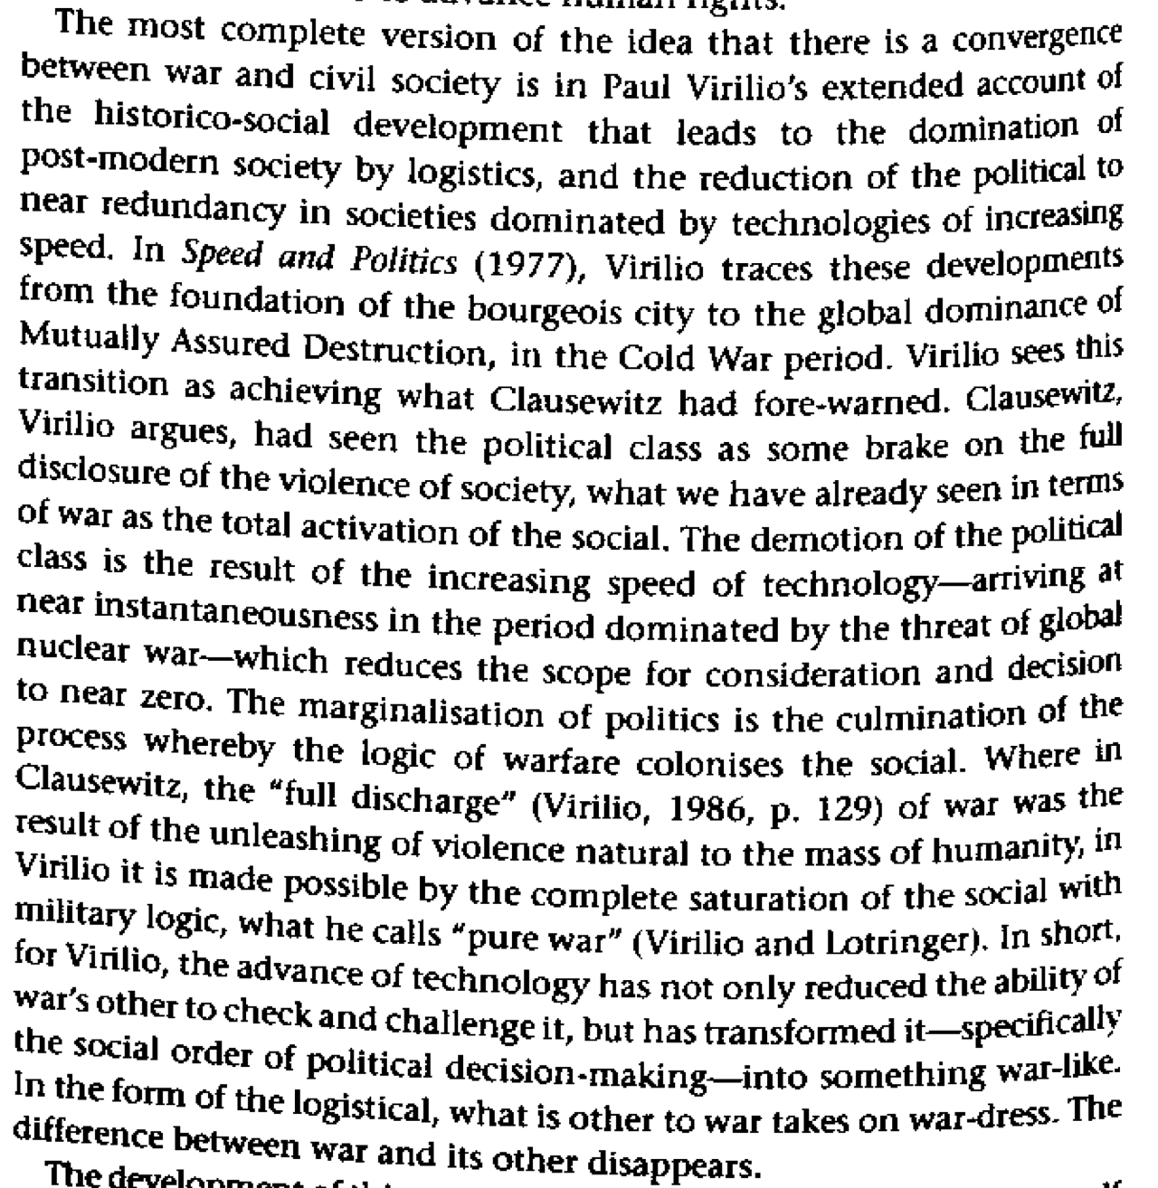

War should not be measured in terms of territory, but the ability to sustain potential sites of power assertion. Just because our troops aren’t in a certain location doesn’t change the fact that the US military could literally destroy anything it wants to, at any time.
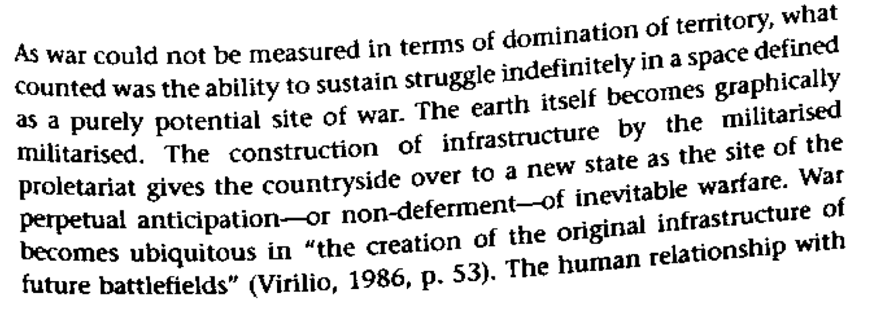
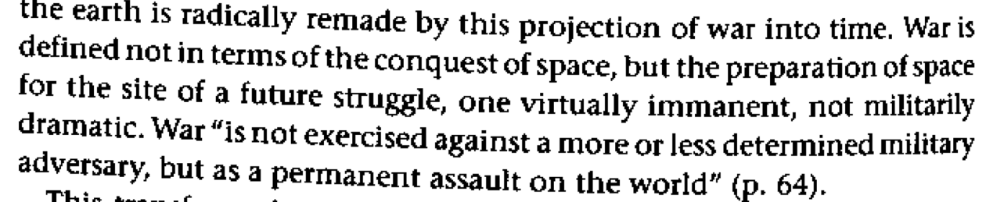
Mansfield 8 (Nick, Profesor of Cultural Studies at Macquarie University in Sydney, Australia, Theorizing War: From Hobbes to Bandiou p. 131-132) CS

Link: nukes
Nuclear weapons fundamentally changed social relations. The United States no longer needs deployed troops to maintain a stranglehold over international relations. Only the alt solves the politics behind logistics and military planning that have become the meaning of war.
Mansfield 8 (Nick, Profesor of Cultural Studies at Macquarie University in Sydney, Australia, Theorizing War: From Hobbes to Bandiou p. 133) CS
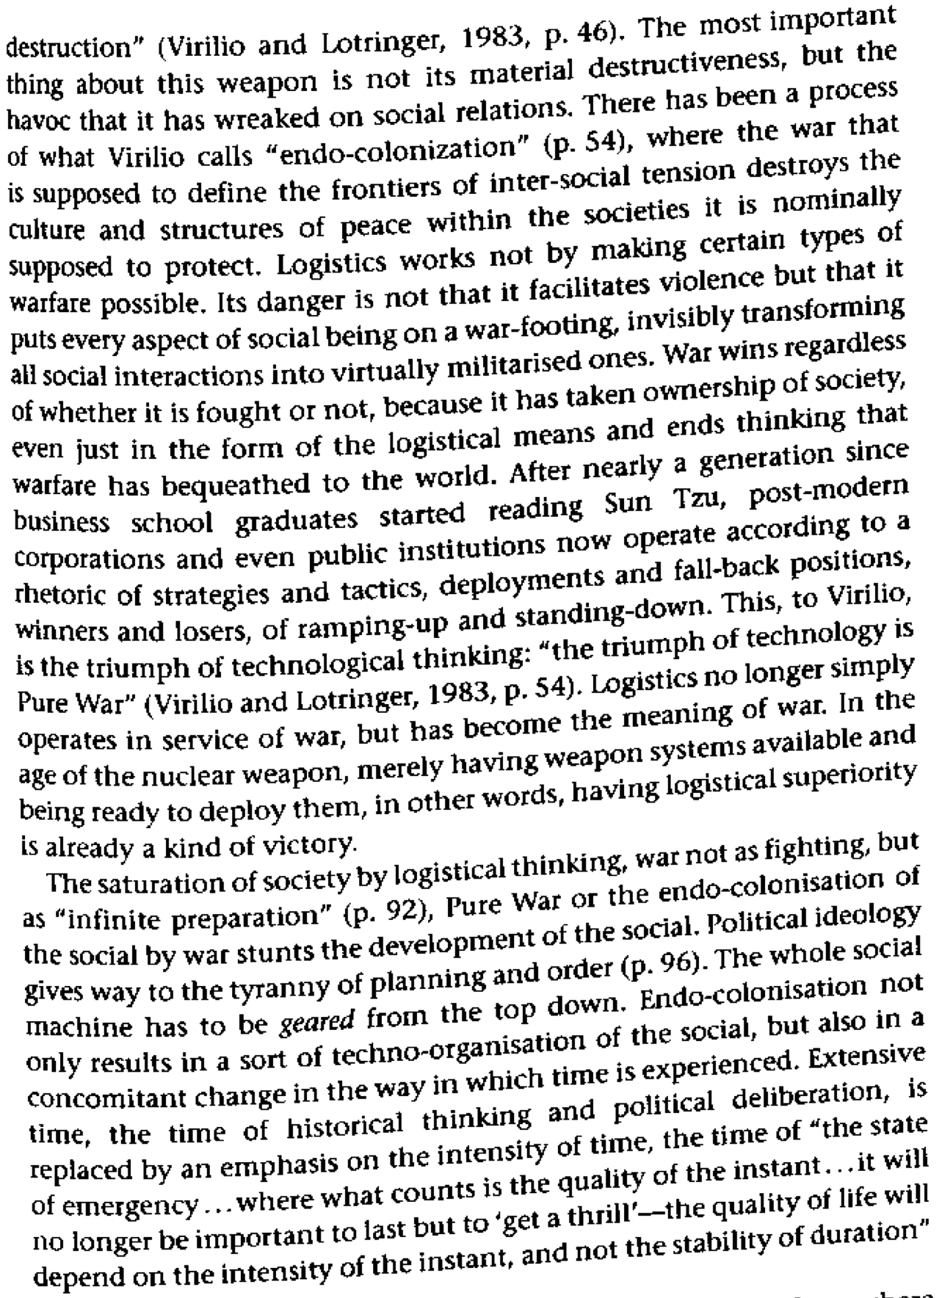
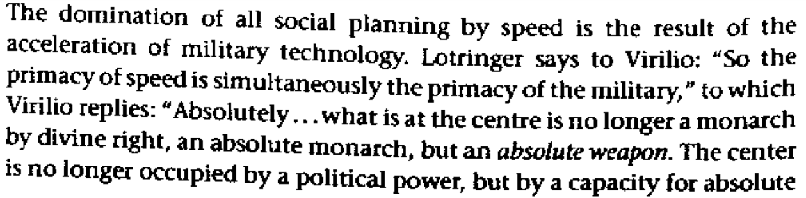

Link: international/domestic dichotomy
Foreign policy constructs social space that seperates the international from the domestic, even the affs benign attempt at being progressive gets coopted and used to formalize difference.
Campbell 5 (David, professor of cultural and political geography at Durham, “The Biopolitics of Security: Oil, Empire, and the Sports Utility Vehicle”, Foreign Policy, Security, and Identity: From Geopolitics to Biopolitics, American Quarterly 57.3) CS
As an imagined community, the state can be seen as the effect of formalized practices and ritualized acts that operate in its name or in the service of its ideals. This understanding, which is enabled by shifting our theoretical commitments from a belief in pregiven subjects to a concern with the problematic of subjectivity, renders foreign policy as a boundary-producing political performance in which the spatial domains of inside/outside, self/other, and domestic/foreign are constituted through the writing of threats as externalized dangers. [End Page 947]
The narratives of primary and stable identities that continue to govern much of the social sciences obscure such an understanding. In international relations these concepts of identity limit analysis to a concern with the domestic influences on foreign policy; this perspective allows for a consideration of the influence of the internal forces on state identity, but it assumes that the external is a fixed reality that presents itself to the pregiven state and its agents. In contrast, by assuming that the identity of the state is performatively constituted, we can argue that there are no foundations of state identity that exist prior to the problematic of identity/difference that situates the state within the framework of inside/outside and self/other. Identity is constituted in relation to difference, and difference is constituted in relation to identity, which means that the "state," the "international system," and the "dangers" to each are coeval in their construction.
Over time, of course, ambiguity is disciplined, contingency is fixed, and dominant meanings are established. In the history of U.S. foreign policy—regardless of the radically different contexts in which it has operated—the formalized practices and ritualized acts of security discourse have worked to produce a conception of the United States in which freedom, liberty, law, democracy, individualism, faith, order, prosperity, and civilization are claimed to exist because of the constant struggle with and often violent suppression of opponents said to embody tyranny, oppression, anarchy, totalitarianism, collectivism, atheism, and barbarism.
This record demonstrates that the boundary-producing political performance of foreign policy does more than inscribe a geopolitical marker on a map. This construction of social space also involves an axiological dimension in which the delineation of an inside from an outside gives rise to a moral hierarchy that renders the domestic superior and the foreign inferior. Foreign policy thus incorporates an ethical power of segregation in its performance of identity/difference. While this produces a geography of "foreign" (even "evil") others in conventional terms, it also requires a disciplining of "domestic" elements on the inside that challenge this state identity. This is achieved through exclusionary practices in which resistant elements to a secure identity on the "inside" are linked through a discourse of "danger" with threats identified and located on the "outside." Though global in scope, these effects are national in their legitimation.12

Link: state centrism/AT: framework
Statecentric geopolitcs do not recognize that the map has been imposed on the world, and not the other way around. These commitments are a normative acceptance of a divided world.
Shapiro 97 (Michael, VIOLENT CARTOGRAPHIES: Mapping Cultures of War, p. 15-16) CS
Michel Foucault put the matter of geographic partisanship succinctly when he noted that "territory is no doubt a geographical notion, but it is first of all a juridico-political one: the area controlled by a certain kind of power."41 Now that global geographies are in flux, as political boundaries become increasingly ambiguous and contested, the questions of power and right are more in evidence with respect to the formerly pacified spaces of nation-states. The "pacification" was violent, but the violent aspects have been suppressed because the narratives and conceptualizations of familiar political science discourses of comparative politics and international relations, which have been aphasic with respect to indigenous peoples, have been complicit with the destruction of indigenous peoples and their practices. While these discourses now appear increasingly inadequate, it is less the case that they have been made invalid by changes in the terrains to which they were thought to refer than it is that the extended period of relative geopolitical stability during the cold war discouraged reflection on the spatial predicates of their intelligibility. Statecentric academic, official, and media political discourses approached adequacy only in their role of legitimating the authority of nation-states. Helping to contain ethical and political conversations within the problematics that served the centralizing authorities of states and the state system, they were complicit in reproducing modernity's dominant, territorial imaginary. To recognize that the dominant geopolitical map has been imposed on the world by power rather than simply emerging as an evolutionary historical inevitablity, as the dominant consensual narratives would have it, one needs to achieve an effective conceptual distance, to think outside of the state system's mode of global comprehension, outside of the spatial predicates of its structures of power, authority, and recognition.42 As Henri Lefebvre has noted, space, especially for those occupying it, tends to have an air of neutrality, to appear empty of normative imposition, as "the epitome of rational abstraction . . . because it has already been occupied and used, and has already been the focus of past processes whose traces are not always evident in the landscape."43 To the extent that the nation-state geography remains descriptive (what some call "realistic") and ahistorical, the ethics and politics of space remain unavailable to political contention. More specifically, this resistance to the geographic imaginary's contribution to ethical assumptions makes it difficult to challenge the prevailing political and ethical discourses of rights, obligations, and proprieties that constitute the normativity of the state. Nevertheless, the spatial practices of the state—its divisions into official versus unofficial space, local versus national space, industrial versus leisure space—are commitments that are as normative as the spatiality of the Christian imaginary, which divided the world into sacred and profane spaces.

Link: afghanistan

To Little, Too late. The Afghani government is caught in a war-repression schema, having no other path than to perpetuate infinitely the war that was its origin.
Mansfield 8 (Nick, Profesor of Cultural Studies at Macquarie University in Sydney, Australia, Theorizing War: From Hobbes to Bandiou p. 121-122) CS
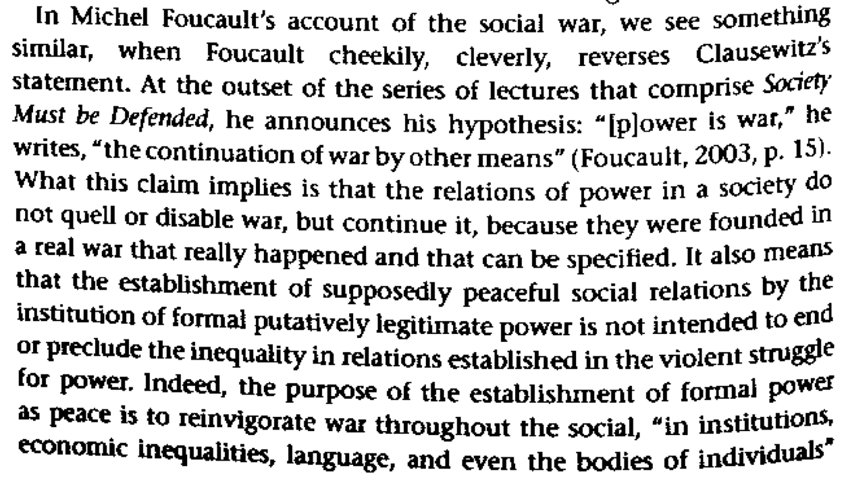
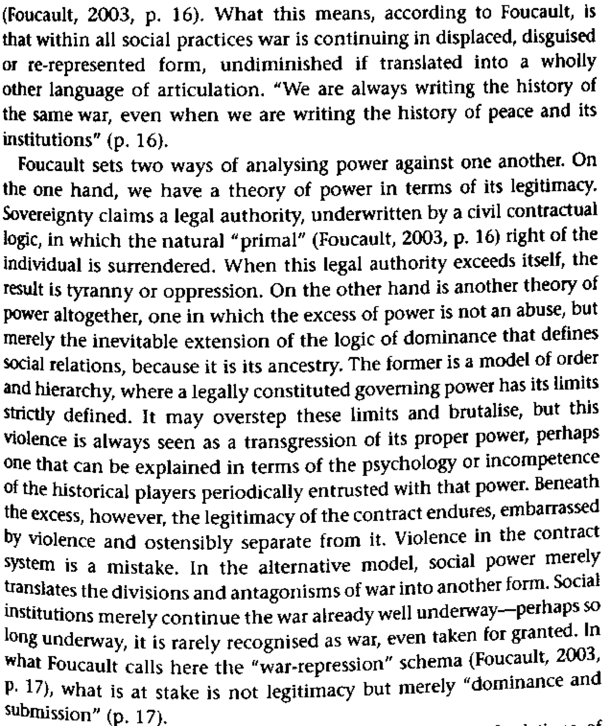

Link: presence
The aff reduces relations to only two points – the beginning and the end. This view of the world is blind to actions themselves, allowing nation states to be unbelievably violent with no recourse.
Schinkel 4 (Willem, Erasmus University Rotterdam, The Netherlands, Vol. 8(1): 5–31; 1362–4806, Theoretical Criminology, The will to violence, p. 16) CS
As soon as there is a need to state explicitly what one wants to do, all comes down to an effort to explain violence, which is indeed a search for causes. Yet thereby two things are lost. The first is a real focus on the meaning of violence. This has been indicated by more phenomenologically oriented researchers, and an example of a study that does focus on the (moral) meanings of violence is Jack Katz’s Seductions of Crime (1999). But still, there too, these ‘meanings’ are located outside violence itself in the sense that violence is studied not because of its intrinsic ‘meaning’, but rather as something referring to a meaning outside itself. So the second thing that is lost in contemporary research—and this is what I believe is really ‘lost’ with very few exceptions in social science—is the violence itself, since it is not being studied in a formalist way. The main problem with such differing perspectives as rational choice theory or theories of masculinity, for example, is that they reduce actions to means–end relations of some kind (either as rationally calculated goals or as furthering an identity of masculinity). This is one way in which the researcher is totally blind for the action itself. The violence ‘itself’: that which remains when all causes are revealed, when external connections are uncovered, such as means–end relations, or meaning-facilitating constructions. What then remains is surely what one might consider as the most ‘disturbing’ of all: a violence for the sake of itself, without morality, extrinsic meaning, but purely destructive. Evil, we might call it. Perhaps that is why this aspect of violence has been carefully avoided in the social sciences. We are afraid of it. We desperately try to explain all there is to violence, to come to a maximum of explained variance, but we know it will not happen for a 100 percent, we know it will never be enough. And when it comes to violence, that residue scares the hell out of us.

Link - Afghanistan War – Repression Schema K
To Little, Too late. The Afghani government is caught in a war-repression schema, having no other path than to perpetuate infinitely the war that was its origin.
Mansfield 8 (Nick, Profesor of Cultural Studies at Macquarie University in Sydney, Australia, Theorizing War: From Hobbes to Bandiou p. 121-122) CS

Impact: violence
Former Yugoslavia proves that negative peace cannot solve the root cause of violence but only recreates it.
Sandy & Perkins 1 (Leo R and Ray, Co-Founder of Peace Studies at Plymouth State College and teacher of philosophy at Plymouth State College, “The Nature of Peace and it’s implication for peace education”, online journal of peace and conflict resolution 4.2, http://www.uio.no/studier/emner/jus/jus/ENGSEMJ/v08/undervisningsmateriale/IL%20&%20HR/Topic%202%20-%20Reading.pdf, 2001
Another way of thinking about peace is to have it defined in negative and positive terms. Peace as the mere absence of war is what Woolman (1985) refers to as “negative peace.” This definition is based on Johan Galtung’s ideas of peace. For Galtung, negative peace is defined as a state requiring a set of social structures that provide security and protection from acts of direct physical violence committed by individuals, groups or nations. The emphasis is ...on control of violence. The main strategy is dissociation, whereby conflicting parties are separated...In general, policies based on the idea of negative peace do not deal with the causes of violence, only its manifestations. Therefore, these policies are thought to be insufficient to assure lasting conditions of peace. Indeed, by suppressing the release of tensions resulting from social conflict, negative peace efforts may actually lead to future violence of greater magnitude. (Woolman, 1985, p.8) The recent wars in the former Yugoslavia are testimony to this. The massive military machine previously provided by the U.S.S.R. put a lid on ethnic hostilities yet did nothing to resolve them thus allowing them to fester and erupt later.

Impact: violence
The aff’s attempt to resolve conflicts only recreates violence
Gur-Ze’ev 1 (Ilan Gur-Ze’ev, Head of the Department of Education at the University of Haifa,” Philosophy of peace education in a postmodern era” ,Summer 2001, http://construct.haifa.ac.il/~ilangz/peace23.html)
It is also important to question the unproblematic introduction of conflict resolution skills and knowledge. From the postmodern perspective these strategies are revealed as one of many conflicting voices fighting over the position of silencing their Others, in a context of constant semiotic bombardment. Peace education is unveiled as a position situated in the narrativization of the individual and collective "self". As such, it is part and parcel of the conflicting violences competing over hegemony. In this space hegemony ensures its own veiling as violence by producing its justification, or in the case of a final defeat of its rivals by ensuring totality, closure, sameness, harmonious order, and "peace". In relation to Levinas's concept of war we can say that in "peace" the "same does not find again its priority over the other" since the otherness of the Other has totally vanished. (64) This is where the project of conflict resolution skills within peace education is situated. Propagating and bestowing conflict resolution "skills" is ultimately nothing less than a mode of violence which is committed to reproducing the present order of things and its ideals. There is no room here for the totally other except for the given facts, quests, and ideological horizons. This holds as long as it is instrumental and effective, yet it is precisely where it is practically most needed that its impotence is most dramatically manifested. This is manifested in the case of the Israeli/Palestinian struggle. In not even one of the many peace education projects in this spot on the globe is there an attempt to challenge the dialectics of the Israeli Independence Day and its concept of the Holocaust-Exile-Redemption, or the Palestinian concept of the Nakbah. The violences of the two representation systems of the conflicting memories and their instrumentalizations within the rival ethnocentric collectives (65) are taken for granted by all of today's peace education projects. Conflict resolution skills education is threatened even by approaching an issue such as relating to the national day of triumph/defeat. It fears treating it as part of the questioning of who are "we" and what is worthy life or death for “us”. It turns away from questions such as what kind of togetherness is possible/bearable/longed-for and what are the ways to approach such a future - along "practical" questions which are for each of the parties fundamentally life-and death struggle worthy questions. It refuses questioning the language that should be the language of the dialogue/conflict or: what are the starting points, the horizons and the aims of the dialogue/struggle within which peace education is promoted/rejected?

The conception of peace enforced by the nuclear threats of the affirmative causes massive violence to maintain its self
Sandy & Perkins 1 (Leo R and Ray, Co-Founder of Peace Studies at Plymouth State College and teacher of philosophy at Plymouth State College, “The Nature of Peace and it’s implication for peace education”, online journal of peace and conflict resolution 4.2, http://www.uio.no/studier/emner/jus/jus/ENGSEMJ/v08/undervisningsmateriale/IL%20&%20HR/Topic%202%20-%20Reading.pdf, 2001
The subsequent suppression of mutual hostile feelings is not taken into account by those who define peace so simply. Their stance is that as long as people are not actively engaged in overt, mutual, violent, physical and destructive activity, then peace exists. This, of course, is just another way of defining cold war. In other words, this simplistic definition is too broad because it allows us to attribute the term “peace” to states of affairs that are not truly peaceful (Copi and Cohen, p. 194). Unfortunately, this definition of peace appears to be the prevailing one in the world. It is the kind of peace maintained by a “peace through strength” posture that has led to the arms race, stockpiles of nuclear weapons, and the ultimate threat of mutually assured destruction. This version of peace was defended by the “peacekeeper”--a name that actually adorns some U.S. nuclear weapons deployed since 1986.1 Also, versions of this name appear on entrances to some military bases. Keeping “peace” in this manner evokes the theme in Peggy Lee’s old song, “Is That All There is?” What this really comes down to is the idea of massive and indiscriminate killing for peace, which represents a morally dubious notion if not a fault of logic. The point here is that a “peace” which depends upon the threat and intention to kill vast numbers of human beings is hardly a stable or justifiable peace worthy of the name. Those in charge of waging war know that killing is a questionable activity. Otherwise, they would not use such euphemisms as “collateral damage” and “smart bombs” to obfuscate it.

Impact: environment
Their mentality that ignores structural militarism also ignores the way that we are complicit with destroying the environment.
Cuomo 96. Chris J. Cuomo, professor of philosophy at the University of Georgia, “War Is Not Just an Event: Reflections on the Significance of Everyday Violence,” Hypatia, Vol. 11, No. 4, Women and Violence (Autumn, 1996), pg. 30-45, jstor
The feminization, commodification, and devaluation of nature helps create a reality in which its destruction in warfare is easily justified. In imagining an ethic that addresses these realities, feminists cannot neglect the extent to which military ecocide is connected, conceptually and practically, to transnational capitalism and other forms of human oppression and exploitation. Virtually all of the world’s thirty-five nuclear bomb test sites, as well as most radioactive dumps and uranium mines, occupy Native lands (Thomas 1995, 6). Six multinationals control one-quarter of all United States defense con- tracts (Thomas 1995, lo), and two million dollars per minute is spent on the global military (Thomas 1995, 7). One could go on for volumes about the effects of chemical and nuclear testing, military-industrial development and waste, and the disruption of wildlife, habitats, communities, and lifestyles that are inescapably linked to military practices.

Impact: dehumanization
Dehumanization comes with the advancement in technology, we replace nature will something that would stand the passage of time. With the removal of these natural limits we know longer can see the problem before we see the aftermath of our decisions
Virilio 95. Paul Virilio, Director of the Ecole Speciale d’Architecutre, Paris, The Art of the Motor
The war of total mobilization was obviously well worth winning against Nazism with its racial and eugenic goals, but it was also the main catalyst in the development of a purely statistical notion of INFORMATION due to the strategic necessities of intelligence, and thus led to the gradual spread of a SOCIOPOLITICAL CYBERNETICS that tends to eliminate not only the weak, but also the component of free will in human work, promoting, as we have seen, so- called "interactive user- friendliness." This is just a metaphor for the subtle enslavement of the human being to "intelligent" machines; a programmed symbiosis of man and computer in which assistance and the much trumpeted "dialogue between man and the machine" scarcely conceal the premises: not of an avowed racial discrimination this time so much as of the total, unavowed disqualification of the human in favor of the definitive instrumental conditioning of the individual.

Impact: nihilism
Reduced presence is caught in an ethical and pragmatic paradox. This strategy enframes technology and being in such a way that it necessitates nhilism.
Burke 7 (Senior Lecturer in Politics and IR, University of New South Wales, Anthony, Theory & Event, 10.2) CS
I see such a drive for ontological certainty and completion as particularly problematic for a number of reasons. Firstly, when it takes the form of the existential and rationalist ontologies of war, it amounts to a hard and exclusivist claim: a drive for ideational hegemony and closure that limits debate and questioning, that confines it within the boundaries of a particular, closed system of logic, one that is grounded in the truth of being, in the truth of truth as such. The second is its intimate relation with violence: the dual ontologies represent a simultaneously social and conceptual structure that generates violence. Here we are witness to an epistemology of violence (strategy) joined to an ontology of violence (the national security state). When we consider their relation to war, the two ontologies are especially dangerous because each alone (and doubly in combination) tends both to quicken the resort to war and to lead to its escalation either in scale and duration, or in unintended effects. In such a context violence is not so much a tool that can be picked up and used on occasion, at limited cost and with limited impact -- it permeates being.
This essay describes firstly the ontology of the national security state (by way of the political philosophy of Thomas Hobbes, Carl Schmitt and G. W. F. Hegel) and secondly the rationalist ontology of strategy (by way of the geopolitical thought of Henry Kissinger), showing how they crystallise into a mutually reinforcing system of support and justification, especially in the thought of Clausewitz. This creates both a profound ethical and pragmatic problem. The ethical problem arises because of their militaristic force -- they embody and reinforce a norm of war -- and because they enact what Martin Heidegger calls an 'enframing' image of technology and being in which humans are merely utilitarian instruments for use, control and destruction, and force -- in the words of one famous Cold War strategist -- can be thought of as a 'power to hurt'.¹⁹ The pragmatic problem arises because force so often produces neither the linear system of effects imagined in strategic theory nor anything we could meaningfully call security, but rather turns in upon itself in a nihilistic spiral of pain and destruction. In the era of a 'war on terror' dominantly conceived in Schmittian and Clausewitzian terms,²⁰ the arguments of Hannah Arendt (that violence collapses ends into means) and Emmanuel Levinas (that 'every war employs arms that turn against those that wield them') take on added significance. Neither, however, explored what occurs when war and being are made to coincide, other than Levinas' intriguing comment that in war persons 'play roles in which they no longer recognises themselves, making them betray not only commitments but their own substance'. 21

turns the case
Our Kritik turns the case—using methods informed by their corrupt notion of presence guarantees failure—Vietnam proves.
Spanos 2k. William V. Spanos, professor of philosophy at Binghampton University, New York, America’s Shadow pg. 150
Put negatively, the Vietnamese Other refused to resist the American military machine in the binary narrative terms prescribed by the logo- centric discourse of the Occident. Rather, this Eastern Other countered the Occidental discourse and practice of structuration by de-structuring its (anthropo)logic: by a devious practice that drew the will to power informing its "disinterestedness" out as a futile, however destructive, contradiction glaringly visible to the world. Specifically, the NLF and NVA chose a strategy of absence (of invisibility, of silence) in the face of a massive and formidable military force that, whatever its exceptionalist claims, was utterly and pervasively inscribed by a European cultural narrative of presence. I mean the "Roman" narrative of decidability, the (meta-physical) logical economy of which articulates, at the site of mili- tary practice, a distanced and totalized field of directional references and coordinates that facilitates an end (or objective) understood as the deci- sive battle. The strategy of the Vietnamese Other, on the other hand, was analogous to that of the Eastern martial arts (most notably those deriv- ing from the Tao), which, grounded on a comportment toward being that acknowledges the harmonious belongingness of being and noth- ing, privilege a "passivity" that allows the aggressor to defeat himself.39 Based on the predictability of the American reaction, this "feminine" Vietnamese strategy of resistance fragmented and disarticulated a totalized military structure inscribed by a logocentric ontology and its privileged panoptic vision and oriented futurally toward a preconceived and decisive end: victory.40

Alt - Question
Our alt is to question the hegemonic discourses that inform the politics of the aff
Burke 7 (Senior Lecturer in Politics and IR, University of New South Wales, Anthony, Theory & Event, 10.2) CS
But is there a way out? Is there no possibility of agency and choice? Is this not the key normative problem I raised at the outset, of how the modern ontologies of war efface agency, causality and responsibility from decision making; the responsibility that comes with having choices and making decisions, with exercising power? (In this I am much closer to Connolly than Foucault, in Connolly's insistence that, even in the face of the anonymous power of discourse to produce and limit subjects, selves remain capable of agency and thus incur responsibilities.⁸⁸) There seems no point in following Heidegger in seeking a more 'primal truth' of being -- that is to reinstate ontology and obscure its worldly manifestations and consequences from critique. However we can, while refusing Heidegger's unworldly⁸⁹ nostalgia, appreciate that he was searching for a way out of the modern system of calculation; that he was searching for a 'questioning', 'free relationship' to technology that would not be immediately recaptured by the strategic, calculating vision of enframing. Yet his path out is somewhat chimerical -- his faith in 'art' and the older Greek attitudes of 'responsibility and indebtedness' offer us valuable clues to the kind of sensibility needed, but little more.
When we consider the problem of policy, the force of this analysis suggests that choice and agency can be all too often limited; they can remain confined (sometimes quite wilfully) within the overarching strategic and security paradigms. Or, more hopefully, policy choices could aim to bring into being a more enduringly inclusive, cosmopolitan and peaceful logic of the political. But this cannot be done without seizing alternatives from outside the space of enframing and utilitarian strategic thought, by being aware of its presence and weight and activating a very different concept of existence, security and action.⁹⁰
This would seem to hinge upon 'questioning' as such -- on the questions we put to the real and our efforts to create and act into it. Do security and strategic policies seek to exploit and direct humans as material, as energy, or do they seek to protect and enlarge human dignity and autonomy? Do they seek to impose by force an unjust status quo (as in Palestine), or to remove one injustice only to replace it with others (the U.S. in Iraq or Afghanistan), or do so at an unacceptable human, economic, and environmental price? Do we see our actions within an instrumental, amoral framework (of 'interests') and a linear chain of causes and effects (the idea of force), or do we see them as folding into a complex interplay of languages, norms, events and consequences which are less predictable and controllable?⁹¹ And most fundamentally: Are we seeking to coerce or persuade? Are less violent and more sustainable choices
AT: alternative doesn’t solve
Realizing the flaws in their conception of presence allows us to formulate large scale resistance and to turn America into a true democracy.
Spanos 2k. William V. Spanos, professor of philosophy at Binghampton University, New York, America’s Shadow pg. 158
To think this ontological unthought of the Vietnam decade is to discover the effective power inhering in a coalition of identityless identities. I mean by this the differential subject positions that acknowledge the social/historical constitution of their identities and, therefore, that confront the question of justice and injustice, equality and inequality, not, as humanists do, on the basis of a universal (and monologic) ontological principle of self-presence, but on the basis of the imbalance(s) of power obtaining in any historically specific occasion.^ It is to realize that only the solidarity of such a "union" of differential identities — of the "historical bloc," as Gramsci puts it — is capable of breaking through the seductive divide-and-conquer (disciplinary) discourse of hegemony, so brilliantly worked out by the founding fathers of the United States. To think the decentering of the subject that occurred in the Vietnam decade, in short, is to realize that such a solidarity of nonessentialist (spectral) identities is, more likely than any form of identity politics, to effect a transformation of the forces of resistance into a "new International" — and "America" into a truly multicultural social democracy.

AT: alternative doesn’t solve
Our critical examination of military presence allows us to interrogate the ways that war pervades society and formulate an effective strategy to resist militarism.
Cuomo 96. Chris J. Cuomo, professor of philosophy at the University of Georgia, “War Is Not Just an Event: Reflections on the Significance of Everyday Violence,” Hypatia, Vol. 11, No. 4, Women and Violence (Autumn, 1996), pg. 30-45, jstor
In raising questions about the relationships between individuals and states, Peach fails to question liberal, modernist conceptions of either. But if individual persons are socially constituted, often in conflicting ways, how can mem- bership, or appropriate loyalties, be determined? If the state is always inevitably a military, patriarchal, racist state, how ought alternative collectivities that will promote the well-being of individuals be conceived without creating or relying on military presence? Feminists concerned with resistances to war need to consider how the pervasiveness of militarism in the construction of the contemporary state implies the need to question nationalism when theorizing critically about war.

AT: alternative doesn’t solve
Building a society around positive peace solves all violence
Sandy & Perkins 1 (Leo R and Ray, Co-Founder of Peace Studies at Plymouth State College and teacher of philosophy at Plymouth State College, “The Nature of Peace and it’s implication for peace education”, online journal of peace and conflict resolution 4.2, http://www.uio.no/studier/emner/jus/jus/ENGSEMJ/v08/undervisningsmateriale/IL%20&%20HR/Topic%202%20-%20Reading.pdf, 2001
Positive peace, in contrast, is “a pattern of cooperation and integration between major human groups....[It] is about people interacting in cooperative ways; it is about social organizations of diverse peoples who willingly choose to cooperate for the benefit of all humankind; it calls for a system in which there are no winners and losers--all are winners; it is a state so highly valued that institutions are built around it to protect and promote it” (O’Kane, 1991-92). It also “involves the search for positive conditions which can resolve the underlying causes of conflict that produce violence” (Woolman, 1985, p.8). The strategies used for this purpose are called “associative,” and they are characterized by “a high level of social interaction [which] enables more rapid resolution of conflict by providing maximum contacts through which solutions may arise” (Woolman, 1985, p.8). Woolman also describes the sort of social reorganization that would provide the best opportunity for real peace. Essentially, he espouses Galtung’s idea of smallness and decentralization of power and authority. Thus, “small scale social organization offers a better environment for encouragement of local autonomy, participation, and high levels of inter-group interaction. Big countries, corporations, and institutions are generally regarded as negative structures because they are prone to depersonalization, excessive centralization of decision-making, and patterns of center-periphery exploitation.” Gene Sharp (1980) in his Social Power and Political Freedom adroitly elaborates these points. The condition of smallness does much to reduce feelings of anonymity and powerlessness. It also facilitates the development of relationships which can restore and preserve community values and spiritual needs which “should take precedence over the materialism that is so central to Western culture.” (Woolman, 1985, p.12). Consistent with these approaches, Reardon (1988) places global justice as the central concept of positive peace and asserts that “justice, in the sense of the full enjoyment of the entire range of human rights by all people, is what constitutes positive peace” (p.26).

AT: alternative doesn’t solve
Our affirmation of positive peace is key to creating a counter education to replace the education of the status quo making positive peace a reality
Gur-Ze’ev 1 (Ilan Gur-Ze’ev, Head of the Department of Education at the University of Haifa,” Philosophy of peace education in a postmodern era” ,Summer 2001, http://construct.haifa.ac.il/~ilangz/peace23.html)
The impetus of counter-education springs from the ethical I. Yet the responsibility of the ethical I has no words; it is pre-rational even if it is always historically embedded.
Counter-education acknowledges that an unavoidable rupture deprives the ethical I of the moral I. (67)There is a rift between the pre-rational ethical responsibility toward the Others and the rational/moral dialogue with the others, which does not negate their otherness. Such a dialogue is not a given reality, it is a Utopia. The Utopia of such a dialogue is a negative Utopia, a concrete negative Utopia.
Only as concrete negative Utopia is the dialogue able to produce a conversation that is not a contingent manifestation of power relations and symbolic economies, that merely reflects the omnipotence, and the whole-presence, of simulacra. Such a negative Utopia acknowledges not only reason, politics, and compromises, but also the presence of power in the formatted, conceptualized, manipulated, otherness of the Other. This is as far as its negative dimension is concerned. As a concrete Utopia it is present as an actual potential to be realized, and it is realizable even in microscopic arenas and for instant hindrances of the continuum. Its historical situatedness enforces its presence within concrete power-relations which it addresses within its openness to infinity, to the totally other than the given reality. These power-relations which govern its context constantly attempt to invade the dialogue, to cause a perpetual distortion that permits no ideal speech situation. As such, the dialogue is committed to transcend the realm of self-evidence and its agencies within the dialogue and its participants. Its awareness of its conceptual and historical situatedness as well as its commitment to reflection and to its own transcendence constitutes a central difference between it and peace education. As such, it cannot avoid being a concrete praxis.

Grassroots activism key to solvency- our advocacy is an important step
Sandy & Perkins 1 (Leo R and Ray, Co-Founder of Peace Studies at Plymouth State College and teacher of philosophy at Plymouth State College, “The Nature of Peace and it’s implication for peace education”, online journal of peace and conflict resolution 4.2, http://www.uio.no/studier/emner/jus/jus/ENGSEMJ/v08/undervisningsmateriale/IL%20&%20HR/Topic%202%20-%20Reading.pdf, 2001
The role of the individual peacemaker from this perspective would involve people who,
“. . . work toward promoting a world in which nonviolent interaction and social equality are the norm. . . . Individuals of conscience should work to create a “trickle up” theory. . . .by starting at the grassroots level to encourage corporate leaders, political figures, and government officials to establish policies promoting peace and justice. This includes not only participating in government by voting, etc., but also standing against a government that does not operate in the best interest of global harmony.” (Trostle, 1992)

AT: Perm
Peace is a process that must start with the alt. Our alternative is specific on the question of sequencing. Examining the underlying causes for war is a precondition to the aff.
Bilgin 5 (Pinar, Assistant Professor, Ph.D, International Politics and Security, University of Wales, “Regional Security in the middle East: A Critical Perspective”, http://www.questia.com/read/108556832?title=Regional%20Security%20in%20the%20 Middle%20East%3a%20%20A%20Critical%20Perspective)
As an analytical move, broadening security entails questioning the military-focused security agendas of Cold War Security Studies and calling for opening up the agenda to include other non-military threats. In making this move, students of critical approaches to security have followed in the footsteps of Peace Researchers who, from the 1960s onwards, had gradually widened their conceptions of peace and violence. Distinguishing between 'negative' and 'positive' peace, John Galtung argued that peace defined as here by the absence of armed conflict is 'negative peace'. 'Positive peace', maintained Galtung, means the absence of not only direct physical violence but also indirect (and sometimes unintentional) 'structural violence' - that is, those socio-economic institutions and relations that oppress human beings by preventing them from realising their potential. Galtung (1969, 1996) also emphasised that to attain 'positive peace', it is not enough to seek to eliminate violence; existing institutions and relations should be geared towards the enhancement of dialogue, cooperation and solidarity among peoples coupled with a respect for the environment. It is also worth noting here that for Galtung (1996:265) peace is not a static concept; it is rather a process (as with security and emancipation for students of critical approaches to security; see Booth 1991b; Wyn Jones 1999). Building upon Peace Researchers' broadening of the concepts of violence and peace that took human beings as the referent, students of critical approaches to security broadened security to include - in Ken Booth's words - 'all those physical and human constraints which stop them from carrying out what they would freely choose to do' (Booth 1991b: 319; Booth 1999b: 40). Such constraints may include human rights abuses, water shortage, illiteracy, lack of access to health care and birth control, militarisation of society, environmental degradation and economic deprivation as well as armed conflict at the state- and sub-state level. Accordingly, the purpose behind broadening security, from a critical perspective, is to become aware of threats to security faced by referents in all walks of life and approach them within a comprehensive and dynamic framework cognisant of the interrelationships in between. Understood as such, broadening security does not simply mean putting more issues on governments' security agendas, but opening up security to provide a richer picture that includes all issues that engender insecurity. In other words, although the broadening of governmental security agendas is an offshoot of broadening security, it is not its main purpose. After all, the US Central Intelligence Agency also broadened its agenda in the 1990s (Johnson 1993), but sought to address them through its traditional practices.
AT: perm
The perm glosses over the structural militarism innate to their narrow conception of what military presence is. Military presence ranges from actual troops to forms of cultural hegemony and market based domination. In order to escape a never-ending cylce of militaristic violence, we must reject the perm for its monolithic conception of presence that glosses over our subtle protest against militarism.
Cuomo 96. Chris J. Cuomo, professor of philosophy at the University of Georgia, “War Is Not Just an Event: Reflections on the Significance of Everyday Violence,” Hypatia, Vol. 11, No. 4, Women and Violence (Autumn, 1996), pg. 30-45, jstor
1) By considering the presence of war and militarism, philosophers and activists are able to engage in a more effective, local, textured, multiplicitous discussion of specific examples and issues of militarism, especially during “peacetime” (when most military activities occur). These include environ- mental effects, such as the recent French decision to engage in nuclear testing; and effects on conceptions of gender and on the lives of women, such as the twelve-year-old Japanese girl who was recently raped by American soldiers stationed in Okinawa.
2 ) Expanding the field of vision when considering the ethical issues of war allows us to better perceive and reflect upon the connections among various effects and causes of militarism, and between aspects of everyday militarism and military activities that generallyoccur between declarations of war and the signing of peace treaties.
3 ) As Robin Schott emphasizes, focusing on the presence of war is particularly necessary given current realities of war, in an age in which military technology makes war less temporally, conceptually, and physically bounded, and in which civil conflict, guerilla wars, ethnic wars, and urban violence in response to worsening social conditions are the most common forms of large- scale violence.
4) Finally, to return to a point which I raised earlier, it is my hope that a more presence-based analysis of war can be a tool for noticing and understanding other political and ethical issues as presences, and not just events. In a recent article in The New Yorker, Henry Louis Gates relays the following:
“You’ve got to start with the families,” [Colin Powell] says of the crisis in the inner cities, “and then you’ve got to fix education so these little bright-eyed five-year-olds, who are innocent as the day is long and who know right from wrong, have all the education they need. And you have to do both these things simultaneously. It’s like being able to support two military conflicts simultaneously.” Military metaphors, the worn currency of political discourse in this country, take on a certain vitality when he deploys them. (Indeed, there are those who argue that much of the General’s allure stems from a sort of transposition of realms. “I think people are hungry for a military solution to inner-city problems,” the black law professor and activist Patricia Williams says.) (Gates 1995, 77)
How (where?when?why?) are institutions of law enforcement like military institutions? How is the presumed constant need for personal protection experienced by some constructed similarly to the necessity of national security? How does the constancy of militarism induce complacency toward or collaboration with authoritative violence? Looking at these questions might help interested parties figure out how to create and sustain movements that are attentive to local realities and particularities about war, about violence, and about the enmeshment of various systems of oppression.
It is of course crucial that the analysis I recommend here notice similarities, patterns, and connections without collapsing all forms and instances of mili- tarism or of state-sponsored violence into one neat picture. It is also important to emphasize that an expanded conception of war is meant to disrupt crisis- based politics that distract attention from mundane, everyday violence that is rooted in injustice. Seeing the constant presence of militarism does not require that middle-class and other privileged Americans suddenly see themselves as constantly under siege. It does require the development of abilities to notice the extent to which people and ecosystems can be severely under siege by military institutions and values, even when peace seems present.
Discourse
Positive peace discourse is key to prevent linguistic violence, not using hate speech merely to comply with political correctness only propagates injustice and violence
Gay 98 (William Gay, University of North Carolina, Charlotte, December 98, “The Practice of Linguistic nonviolence”, Peace Review, 10402659, Dec98, Vol. 10, Issue 4, http://web.ebscohost.com/ehost/detail?vid=7&hid=7&sid=fbf7951e-fa9b-4ac2-ba3b-2c07e8326bd2%40sessionmgr2&bdata=JnNpdGU9ZWhvc3QtbGl2ZQ%3d %3d#db=aph&AN=1426690
Many times the first step in reducing linguistic violence is to simply refrain from thc use of offensive and oppressive terms. However, just because linguistic violence is not being used, a genuinely pacific discourse is not necessarily present. Nonviolent discourse, like the condition of peace, can be negative or positive. "Negative peace" refers to the temporary absence of actual war or the lull between wars, while "positive peace" refers to the negation of war and the presence of justice. The pacific discourse that is analogous to negative peace can actually perpetuate injustice. Broadcasters in local and national news may altogether avoid using terms like "dyke" or "fag" or even "homosexual," but they and their audiences can remain homophobic even when the language of lesbian and gay pride is used. A government may cease referring to a particular nation as "a rogue state," but public and private attitudes may continue to foster prejudice toward this nation and its inhabitants. When prejudices remain unspoken, at least in public thrums, their detection and eradication are made even more difficult. Of course, we need to find ways to restrain hate speech in order to at least stop linguistic attacks in the public arena. Likewise, we need to find ways to restrain armed conflicts and hostile name calling directed against an adversary of the state. However, even if avoidance of linguistic violence is necessary, it is not sufficient. Those who bite their tongues to comply with the demands of political correctness are often ready to lash out vitriolic epithets when these constraints are removed. Thus, the practice of linguistic nonviolence is more like negative peace when the absence of hurtful or harmful terminology merely marks a lull in reliance on linguistic violence or a shift of its use from the public to the private sphere. The merely public or merely formal repression of language and behavior that expresses these attitudes builds up pressure that can erupt in subsequent outbursts of linguistic violence and physical violence.

Positive Peace discourse can solve violence
Gay 98 (William Gay, University of North Carolina, Charlotte, December 98, “The Practice of Linguistic nonviolence”, Peace Review, 10402659, Dec98, Vol. 10, Issue 4, http://web.ebscohost.com/ehost/detail?vid=7&hid=7&sid=fbf7951e-fa9b-4ac2-ba3b-2c07e8326bd2%40sessionmgr2&bdata=JnNpdGU9ZWhvc3QtbGl2ZQ%3d %3d#db=aph&AN=1426690
While linguistic violence often relies on authoritarian, monological, aggressive and calculative methods, a positively nonviolent discourse is democratic, dialogleal, receptive, and mediative. A positively nonviolent discourse is not passive in the sense of avoiding engagement; it is pacific in the sense of seeking to actively build, from domestic to international levels, lasting peace and justice. A positively nonviolent discourse provides a way of perceiving and communicating that frees us to the diversity and open-endedness of life rather than the sameness and senselessness of violence. A positively nonviolent discourse can provide the communicative means to overcome linguistic violence that docs not contradict or compromise its goal at any point during its pursuit. The first step is breaking our silence concerning the many forms of violence. We need to recognize that often silence is violence; frequently, unless we break l he silence, we are being complicitous to the violence of the situation. However, in breaking the silence, our aim should be to avoid counter-violence, in its physical forms and in its verbal forms. Efforts to advance peace and justice should occupy the space between silence and violence. Linguistic violence can be overcome, but the care and vigilance of the positive practice of physical and linguistic nonviolence is needed if the gains are to be substantive, rather than merely formal, and if the goals of nonviolence are to be equally operative in the means whereby we overcome linguistic violence and social injustice.
AT: framework/role of ballot
The alternative exposes ideological technologies and opens up critical space for the articulation of alternative and emancipatory forms of knowledge and practice.
Jackson 7 (Reader in International Politics at Aberystwyth, Richard, Government and Opposition, Vol. 42, No. 3, pp. 425–426,)
The purpose of this article is not to assert that the terrorist threat does not exist or that terrorism and religion are not linked in some fashion. Rather, its central aim is to draw attention to the contestable and politicized character of the dominant narratives, the ways in which ‘Islamic terrorism’ is interpreted and socially constructed as an existential threat and the means by which the broader discourse functions to promote a number of discrete political projects and reify a particular kind of political and social order. Exposing the ideological effects and political technologies of the discourse has the potential to open up critical space for the articulation of alternative and potentially emancipatory forms of knowledge and practice. Moreover, given the enormous material and social destruction of the war on terrorism thus far, the possibility of articulating non-violent or constructive responses to acts of terrorism takes on immense normative significance. Fortunately, discourses are never completely hegemonic; there is always room for counter-hegemonic struggle and subversive forms of knowledge. In this case, not only is the discourse inherently unstable and vulnerable to different forms of critique, but the continual setbacks in Iraq and Afghanistan, ongoing revelations of torture and rendition and increasing resistance to government attempts to restrict civil liberties suggest that the present juncture provides an opportune moment to engage in deliberate and sustained critique. Recent moves by officials of the European Union for example, to review its lexicon of terms regarding ‘Islamic’ or ‘jihadi’ terrorism are indicative of a growing dissatisfaction with the discourse within parts of the political establishment.112 In particular, given their public role, scholars in the field have a responsibility to challenge the articulation of the central labels and narratives of the dominant discourse and to explore alternative forms of language and knowledge. As an initial starting point, reclaiming the labels and narratives of ‘political violence’, ‘revolutionaries’, ‘militants’, ‘nationalism’, ‘anti-imperialism’, ‘self-determination’, ‘insurgency’, ‘ideology’ and the like to describe the current conflict, could provide a more flexible and ethically responsible alternative to the oppressive confines of the discourse of ‘Islamic terrorism’.

AT: framework/role of ballot
Reject their monolithic conception of presence—the question of this debate is who adequately understands the ontological meaning of presence as not simply material, but discursive and metaphysical as well.
Spanos 2k. William V. Spanos, professor of philosophy at Binghampton University, New York, America’s Shadow, pg. 7
By logos, I do not mean a particular historical entity: the Greek or Roman logos, the Christian logos, the humanist logos. I mean, rather, a historically constructed inaugural metaphor of presence or, to empha- size its spatial character, a figure or diagram that is both immanent in and outside of this history, which is to say provisionally, is polyvalent in its practical application. To appropriate Foucault's (contradictory) analysis of a historically specific manifestation of this figure, by logos I mean a "diagram of a mechanism of power reduced to its ideal form,"6 a diagram, that is, that is applicable to any historically specific time and any historically specific condition involving a differential and "errant" multiplicity. The difference between a theological and an anthropological (Enlightenment) metaphysics, to put it provisionally, has to do with each epoch's representation of the difference that the diagram would reduce. The theological era, which was antagonistic toward worldly time — historicity — focused simply on the spatiality of the difference it would structuralize within its Providential History, whereas the Enlightenment, which had to acknowledge the claims of time (the prolific and mutable thisness of the world) focused on the temporality of the difference it would structuralize within its Universal History. In the anthropological epoch, that is to say, temporality assumed, as, for example, in Hegel (and to many of his post-Enlightenment critics), the more complex character of the dialectic or, rather, of the dialectical narrative, to overcome precisely the failure of the theological moment to adequately accommodate the claims of temporality. But in both phases, whatever the degree of complexity, it is the logos as polyvalent diagram of power that presides.

AT: framework
We must interrogate our understanding of Western action through metaphysics in order to truly understand the implications of our actions and discourse.
Spanos 2k. William V. Spanos, professor of philosophy at Binghampton University, New York, America’s Shadow, pg. 8-9
What, then, we are compelled to ask by its historically privileged status, is metaphysics? In attempting an answer to this question, I will not invoke the naturalized definition that is all too often the point of departure of even those who would expose and criticize the will to power that inheres in it. An investigation into the relation between Western ontology and imperialism would be better served by following Heidegger's relentless de-naturalization of the sedimented metaphors that constitute the veridical discourse of (Western) philosophy, that is, by disclosing its etymological origins. In a neglected passage of "What Is Metaphysics?" he writes:
Our inquiry concerning the nothing [das Nichts] should bring us face to face with metaphysics itself. The name "metaphysics" de- rives from the Greek meta-ta-physika. This peculiar title [which, for the Greeks meant the ontic-ontological or in-sistent/ek-sistent disposition of Dasein, the inquiring being] was later interpreted as characterizing the inquiry, the meta or trans extending out "over" beings as such.
And in a separate paragraph that signals the enabling importance of this later revision, he states: "Metaphysics is inquiry beyond or over beings which aims to recover them as such as a whole for our grasp."s

AT: framework
The affirmative’s refusal to engage the underlying ontology behind their assumptions dooms their project to serial policy failure.
Dillon and Reid 2k. Michael Dillon, professor of political science at Lancaster and Julian Reid, lecturer on international relations and professor of political science at King’s College in London; 2000, Alternatives, Volume 25, Issue 1: Global Governance, Liberal Peace, and Complex Emergency
As a precursor to global governance, governmentality, according to Foucault's initial account, poses the question of order not in terms of the origin of the law and the location of sovereignty, as do traditional accounts of power, but in terms instead of the management of population. The management of population is further refined in terms of specific problematics to which population management may be reduced. These typically include but are not necessarily exhausted by the following topoi of governmental power: economy, health, welfare, poverty, security, sexuality, demographics, resources, skills, culture, and so on. Now, where there is an operation of power there is knowledge, and where there is knowledge there is an operation of power. Here discursive formations emerge and, as Foucault noted, in every society the production of discourse is at once controlled, selected, organised and redistributed by a certain number of procedures whose role is to ward off its powers and dangers, to gain mastery over its chance events, to evade its ponderous, formidable materiality.[ 34] More specifically, where there is a policy problematic there is expertise, and where there is expertise there, too, a policy problematic will emerge. Such problematics are detailed and elaborated in terms of discrete forms of knowledge as well as interlocking policy domains. Policy domains reify the problematization of life in certain ways by turning these epistemically and politically contestable orderings of life into "problems" that require the continuous attention of policy science and the continuous resolutions of policymakers. Policy "actors" develop and compete on the basis of the expertise that grows up around such problems or clusters of problems and their client populations. Here, too, we may also discover what might be called "epistemic entrepreneurs." Albeit the market for discourse is prescribed and policed in ways that Foucault indicated, bidding to formulate novel problematizations they seek to "sell" these, or otherwise have them officially adopted. In principle, there is no limit to the ways in which the management of population may be problematized. All aspects of human conduct, any encounter with life, is problematizable. Any problematization is capable of becoming a policy problem. Governmentality thereby creates a market for policy, for science and for policy science, in which problematizations go looking for policy sponsors while policy sponsors fiercely compete on behalf of their favored problematizations. Reproblematization of problems is constrained by the institutional and ideological investments surrounding accepted "problems," and by the sheer difficulty of challenging the inescapable ontological and epistemological assumptions that go into their very formation. There is nothing so fiercely contested as an epistemological or ontological assumption. And there is nothing so fiercely ridiculed as the suggestion that the real problem with problematizations exists precisely at the level of such assumptions. Such "paralysis of analysis" is precisely what policymakers seek to avoid since they are compelled constantly to respond to circumstances over which they ordinarily have in fact both more and less control than they proclaim. What they do not have is precisely the control that they want. Yet serial policy failure--the fate and the fuel of all policy--compels them into a continuous search for the new analysis that will extract them from the aporias in which they constantly find themselves enmeshed.[ 35] Serial policy failure is no simple shortcoming that science and policy--and policy science--will ultimately overcome. Serial policy failure is rooted in the ontological and epistemological assumptions that fashion the ways in which global governance encounters and problematizes life as a process of emergence through fitness landscapes that constantly adaptive and changing ensembles have continuously to negotiate. As a particular kind of intervention into life, global governance promotes the very changes and unintended outcomes that it then serially reproblematizes in terms of policy failure. Thus, global liberal governance is not a linear problem-solving process committed to the resolution of objective policy problems simply by bringing better information and knowledge to bear upon them. A nonlinear economy of power/knowledge, it deliberately installs socially specific and radically inequitable distributions of wealth, opportunity, and mortal danger both locally and globally through the very detailed ways in which life is variously (policy) problematized by it.

AT: framework
The rapid speed of today’s information based and electronic politics makes legitimate political praxis utterly impossible—only our alternative can make politics meaningful again. Their form of politics, instead, relies on totalitarian statism.
Virilio 02. Paul Virilio, Director of the Ecole Speciale d’Architecutre, Paris, Desert Screen: War at the Speed of Light, pg. 43-44
P.V.: The threat is that of fusion and confusion. No politics is possible at the scale of the speed of light. Politics depends upon having time for reflection. Today, we no longer have time to reflect, the things that we see have already happened. And it is necessary to react immediately. Is a real-time democracy possible? An authoritarian politics, yes. But what defines democracy is the sharing power. When there is no time to share what will be shared? Emotions.
A change in our relationship to time has recently taken place. Before, we had the past, the present, and the future. Today, the choice is nothing more than that between deferred time and real time. Humanity no longer lives in the present, but rather in the tele-presence of the world. On the level of morality, of aesthetics, of ethics, major political questions immediately arise.
This change and this acceleration have modified the conduct of war. Ancient war depended upon the citzen-soldier. Progressively with automated destruction and nuclear weapons that impose a dramatically shortened period of decision, we have delegated political power of the major states to a single man, the head of the state, who himself delegates the execution to a machine. Soon, war will be waged by automatic answering machines. The new weapons being designed will strike their objectives with a lightning speed of nanoseconds or milliseconds. At the speed of light, man can neither see the weapon arrive nor fend off the attack.

AT: framework
It’s an prior ethical question to the plan that they use a proper frame of analysis to understand militarism.
Cuomo 96. Chris J. Cuomo, professor of philosophy at the University of Georgia, “War Is Not Just an Event: Reflections on the Significance of Everyday Violence,” Hypatia, Vol. 11, No. 4, Women and Violence (Autumn, 1996), pg. 30-45, jstor
Feminist ethical questions about war are not reducible to wondering how to avoid large-scale military conflict despite human tendencies toward violence. Instead, the central questions concern the omnipresence of militarism, the possibilities of making its presence visible, and the potential for resistance to its physical and hegemonic force. Like “solutions” to the preponderance of violence perpetrated by men against women that fail to analyze and articulate relationships between everyday violence and institutionalized or invisible systems of patriarchal, racist, and economic oppression, analyses that charac- terize eruptions of military violence as isolated, persistent events, are practi- cally and theoretically insufficient.

AT: framework—war on terror/middle east (1/2)
The War on Terror fundamentally changed the relationship between the United States and the rest of the world. Once a place of intellectual freedom, the academy has become professionalized by the encroachment of nationalist and statist agendas - cementing ideologically restrictions which limit our ability to challenge bureaucratic role playing. No reorientation of troops can change the logic instilled by this conflict. Only a politics that challenges this type of academia has the revolutionary potential to recast what it means to be American.
Biswas 7 (Shampa, Associate Professor at Whitman College, 07 [Empire and Global Public Intellectuals: Reading Edward Said as an International Relations Theorist, Millennium - Journal of International Studies 2007]
One of the profound effects of the war on terror initiated by the Bush administration has been a significant constriction of a democratic public sphere, which has included the active and aggressive curtailment of intellectual and political dissent and a sharp delineation of national boundaries along with concentration of state power. The academy in this context has become a particularly embattled site with some highly disturbing onslaughts on academic freedom. At the most obvious level, this has involved fairly well-calibrated neoconservative attacks on US higher education that have invoked the mantra of ‘liberal bias’ and demanded legislative regulation and reform10, an onslaught supported by a well-funded network of conservative think tanks, centres, institutes and ‘concerned citizen groups’ within and outside the higher education establishment11 and with considerable reach among sitting legislators, jurists and policy-makers as well as the media. But what has in part made possible the encroachment of such nationalist and statist agendas has been a larger history of the corporatisation of the university and the accompanying ‘professionalisation’ that goes with it. Expressing concern with ‘academic acquiescence in the decline of public discourse in the United States’, Herbert Reid has examined the ways in which the university is beginning to operate as another transnational corporation12, and critiqued the consolidation of a ‘culture of professionalism’ where academic bureaucrats engage in bureaucratic role-playing, minor academic turf battles mask the larger managerial power play on campuses and the increasing influence of a relatively autonomous administrative elite and the rise of insular ‘expert cultures’ have led to academics relinquishing their claims to public space and authority.13 While it is no surprise that the US academy should find itself too at that uneasy confluence of neoliberal globalising dynamics and exclusivist nationalist agendas that is the predicament of many contemporary institutions around the world, there is much reason for concern and an urgent need to rethink the role and place of intellectual labour in the democratic process. This is especially true for scholars of the global writing in this age of globalisation and empire. Edward Said has written extensively on the place of the academy as one of the few and increasingly precarious spaces for democratic deliberation and argued the necessity for public intellectuals immured from the seductions of power.14 Defending the US academy as one of the last remaining utopian spaces, ‘the one public space available to real alternative intellectual practices: no other institution like it on such a scale exists anywhere else in the world today’15, and lauding the remarkable critical theoretical and historical work of many academic intellectuals in a lot of his work, Said also complains that ‘the American University, with its munificence, utopian sanctuary, and remarkable diversity, has defanged (intellectuals)’16. The most serious threat to the ‘intellectual vocation’, he argues, is ‘professionalism’ and mounts a pointed attack on the proliferation of ‘specializations’ and the ‘cult of expertise’ with their focus on ‘relatively narrow areas of knowledge’, ‘technical formalism’, ‘impersonal theories and methodologies’, and most worrisome of all, their ability and willingness to be seduced by power.17 Said mentions in this context the funding of academic programmes and research which came out of the exigencies of the Cold War18, an area in which there was considerable traffic of political scientists (largely trained as IR and comparative politics scholars) with institutions of policy-making. Looking at various influential US academics as ‘organic intellectuals’ involved in a dialectical relationship with foreign policy-makers and examining the institutional relationships at and among numerous think tanks and universities that create convergent perspectives and interests, Christopher Clement has studied US intervention in the Third World both during and after the Cold War made possible and justified through various forms of ‘intellectual articulation’.19 This is not simply a matter of scholars working for the state, but indeed a larger question of intellectual orientation. It is not uncommon for IR scholars to feel the need to formulate their scholarly conclusions in terms of its relevance for global politics, where ‘relevance’ is measured entirely in terms of policy wisdom. Edward Said’s searing indictment of US intellectuals – policy-experts and Middle East experts - in the context of the first Gulf War20 is certainly even more resonant in the contemporary context preceding and following the 2003 invasion of Iraq. The space for a critical appraisal of the motivations and conduct of this war has been considerably diminished by the expertise-framed national debate wherein certain kinds of ethical questions irreducible to formulaic ‘for or against’ and ‘costs and benefits’ analysis can simply not be raised. In effect, what Said argues for, and IR scholars need to pay particular heed to, is an understanding of ‘intellectual relevance’ that is larger and more worthwhile, that is about the posing of critical, historical, ethical and perhaps unanswerable questions rather than the offering of recipes and solutions, that is about politics (rather than techno-expertise) in the most fundamental and important senses of the vocation. It is not surprising that the ‘cult of expertise’ that is increasingly driving the study of global politics has occurred in conjunction with a larger depoliticisation of many facets of global politics, which since the 1980s has accompanied a more general prosperity-bred complacency about politics in the Anglo-European world, particularly in the US. There are many examples of this. It is evident, for instance, in the understanding of globalisation as TINA market-driven rationality – inevitable, inexorable and ultimately, as Thomas Friedman’s many writings boldly proclaim, apolitical.22 If development was always the ‘anti-politics machine’ that James Ferguson so brilliantly adumbrated more than a decade ago, it is now seen almost entirely as technocratic aid and/or charitable humanitarianism delivered via professionalised bureaucracies, whether they are IGOs or INGOs.23 From the more expansive environmental and feminist-inspired understandings of ‘human security’, understandings of global security are once again increasingly being reduced to (military) strategy and global democratisation to technical recipes for ‘regime change’ and ‘good governance’.

AT: framework—war on terror/middle east (2/2)
There should be little surprise in such a context that the ‘war on terror’ has translated into a depoliticised response to a dehistoricised understanding of the ‘roots of terror’. For IR scholars, reclaiming politics is a task that will involve working against the grain of expertise-oriented professionalism in a world that increasingly understands its own workings in apolitical terms. What Said offers in the place of professionalism is a spirit of ‘amateurism’ – ‘the desire to be moved not by profit or reward but by love for and unquenchable interest in the larger picture, in making connections across lines and barriers, in refusing to be tied down to a specialty, in caring for ideas and values despite the restrictions of a profession’, an amateur intellectual being one ‘who considers that to be a thinking and concerned member of a society one is entitled to raise moral issues at the heart of even the most technical and professionalized activity as it involves one’s country, its power, its mode of interacting with its citizens as well as with other societies’.

AT: framework
The affirmative team acts as an agent of the reproduction of the education of the status quo you must vote neg to break the cycle
Gur-Ze’ev 1 (Ilan Gur-Ze’ev, Head of the Department of Education at the University of Haifa,” Philosophy of peace education in a postmodern era” ,Summer 2001, http://construct.haifa.ac.il/~ilangz/peace23.html)
Normalizing educatitthon is founded on an unchallenged consensus and it is committed to securing its self-evidence. As part of its function it is very important for normalizing education to conceal its foundations and avoid transparency (or secure only a certain kind of critique and transparency, which is the same thing) of the apparatuses it uses. This is in order to reproduce the subjectification or the human subject as some-thing and not as some-one. This process includes the production of his/her potential violence/productivity and the aims, ideals, interests, and strivings for love and peace - as well as categories such as "justice". All these enable the subject to function as an agent of the reproduction of the system. In "peace" the invisibility of the violence, which guarantees the present order, is best secured, the hegemonic violence is unchallenged, and counter-violence is successfully delegitimized. In "peace" the subject is efficiently sent off on the quest to realize her human potentials to become other than what she is constructed to be. In such a "peace" and stable normality (62) forgetfulness rules and humans are not ready to be called upon by their destiny. Normalizing education sets for them the relevant quests, or real dreams, goals, and enemies, and all the rest is a history of struggling efficiencies – until something totally other intervenes and challenges the hegemonic self-evidence and the order of things. The constant subjectification of the subject goes on unchallenged.

The peace education we get from school is wrong and only perpetuates violence. This round is key to breaking down the flawed notions of peace education
Gur-Ze’ev 1 (Ilan Gur-Ze’ev, Head of the Department of Education at the University of Haifa,” Philosophy of peace education in a postmodern era” ,Summer 2001, http://construct.haifa.ac.il/~ilangz/peace23.html)
We claim that the work of the 50 million teachers referred to by UNESCO is one of the main mechanisms of perpetuating violence and injustice. This is not because they are doing such a poor job, but on the contrary, because around the world teachers, together with the other manipulations of normalizing education, are doing it so well. The current human reality is to be challenged by a critical addressing of the fundamentals and the context of the concept of peace that these teachers/educators are committed to, and certainly not by a search for new routes for improving their present "achievements".
Within this trend there is a strong positivistic conviction that conflict resolution skills are a matter of professional knowledge and good didactics. There is here a belief that these skills, fundamentally, might be taught along with the quest for justice, in the most concrete and specific manner. (27) Some of the positivist writers within this trend even see peace education as a successful conflict-solving process in which the decline of violence is to be detected by a measurable promotion of schools' efficiency and productivity.

AT: framework
Violent ontologies dominate the conceptual and political frameworks that define state actions. The aff posits their action as progressive, but in fact it is enframed in an ontology that drives out the possibility of revealing alternative visions of the world. The aff is only deepening the destructive features of contemporary modernity through their calculative discourse.
Burke 7 (Senior Lecturer in Politics and IR, University of New South Wales, Anthony, Theory & Event, 10.2) CS
My argument here, whilst normatively sympathetic to Kant's moral demand for the eventual abolition of war, militates against excessive optimism.⁸⁶ Even as I am arguing that war is not an enduring historical or anthropological feature, or a neutral and rational instrument of policy -- that it is rather the product of hegemonic forms of knowledge about political action and community -- my analysis does suggest some sobering conclusions about its power as an idea and formation. Neither the progressive flow of history nor the pacific tendencies of an international society of republican states will save us. The violent ontologies I have described here in fact dominate the conceptual and policy frameworks of modern republican states and have come, against everything Kant hoped for, to stand in for progress, modernity and reason. Indeed what Heidegger argues, I think with some credibility, is that the enframing world view has come to stand in for being itself. Enframing, argues Heidegger, 'does not simply endanger man in his relationship to himself and to everything that is...it drives out every other possibility of revealing...the rule of Enframing threatens man with the possibility that it could be denied to him to enter into a more original revealing and hence to experience the call of a more primal truth.'⁸⁷
What I take from Heidegger's argument -- one that I have sought to extend by analysing the militaristic power of modern ontologies of political existence and security -- is a view that the challenge is posed not merely by a few varieties of weapon, government, technology or policy, but by an overarching system of thinking and understanding that lays claim to our entire space of truth and existence. Many of the most destructive features of contemporary modernity -- militarism, repression, coercive diplomacy, covert intervention, geopolitics, economic exploitation and ecological destruction -- derive not merely from particular choices by policymakers based on their particular interests, but from calculative, 'empirical' discourses of scientific and political truth rooted in powerful enlightenment images of being. Confined within such an epistemological and cultural universe, policymakers' choices become necessities, their actions become inevitabilities, and humans suffer and die. Viewed in this light, 'rationality' is the name we give the chain of reasoning which builds one structure of truth on another until a course of action, however violent or dangerous, becomes preordained through that reasoning's very operation and existence. It creates both discursive constraints -- available choices may simply not be seen as credible or legitimate -- and material constraints that derive from the mutually reinforcing cascade of discourses and events which then preordain militarism and violence as necessary policy responses, however ineffective, dysfunctional or chaotic.

AT: framework
Their reduction of debate reduces our agency to crisis managers that forget ontology while they exacerbate and deepen conflict.
Spanos 08 (William. American Exceptionalism in the Age of Globalization: The Specter of Vietnam. 2008. Page 237.)


